**Light Sources in Electronics**

Light can be produced and/or controlled electronically in a number of ways. In light emitting diodes ([LEDs](http://hyperphysics.phy-astr.gsu.edu/hbase/Electronic/ledcon.html#c1)), light is produced by a solid state process called [electroluminescence](http://hyperphysics.phy-astr.gsu.edu/hbase/Electronic/led.html#c2). Under speciﬁc conditions, solid state light sources can produce [coherent light, as in laser diodes. Other devices suc](http://hyperphysics.phy-astr.gsu.edu/hbase/Electronic/lasdio.html#c1)h as liquid crystal devices (LCDs) control externally supplied light to form display units.

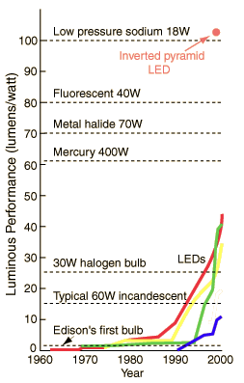Liquid crystal projectors have made a major impact on public presentation of information, making inroads on the venerable cathode ray tubes. Other technologies such as the Texas Instruments' micromirror devices, called "digital light processors" as well as varieties of plasma displays are beginning to enter the market for displays.

Craford, et al. make the case that LED lighting is making lighting. Some types last 100,000 hours, compared to about 1000 hours for an incandescent bulb. Now that blue LEDs have become a reality, white light LEDs can be produced by combining the red, green and blue chips in a single device.

The efﬁciency of a device in converting electrical power to visible light is called "luminous performance" in the illustration, and is measured in [lumens/watt](http://hyperphysics.phy-astr.gsu.edu/hbase/vision/lumpow.html#c2). Low pressure sodium lights have very high efﬁciency because of the dominance of the [sodium d-lines](http://hyperphysics.phy-astr.gsu.edu/hbase/quantum/sodium.html#c2) in the response of sodium vapor. As a tribute to the progress which has been made with LEDs, one type of red LED, the inverted pyramid type developed by Hewlett-Packard has exceeded the efﬁciency of "old yellow", the sodium light.

An electric light is a device that produces [visible light](https://en.wikipedia.org/wiki/Light) from [electric current](https://en.wikipedia.org/wiki/Electric_current). It is the most common form of artificial [lighting](https://en.wikipedia.org/wiki/Lighting) and is essential to modern society, providing interior lighting for buildings and exterior light for evening and nighttime activities. In technical usage, a replaceable component that produces light from electricity is called a lamp. Lamps are commonly called light bulbs; for example, the [incandescent light bulb](https://en.wikipedia.org/wiki/Incandescent_light_bulb). Lamps usually have a base made of ceramic, metal, glass, or plastic, which secures the lamp in the socket of a [light fixture](https://en.wikipedia.org/wiki/Light_fixture). The electrical connection to the socket may be made with a screw-thread base, two metal pins, two metal caps or a bayonet cap.

The three main categories of electric lights are incandescent lamps, which produce light by a [filament](https://en.wikipedia.org/wiki/Incandescent_light_bulb#Filament) heated white-hot by electric current, [gas-discharge lamps](https://en.wikipedia.org/wiki/Gas-discharge_lamp), which produce light by means of an [electric arc](https://en.wikipedia.org/wiki/Electric_arc) through a gas, and [LED lamps](https://en.wikipedia.org/wiki/LED_lamp), which produce light by a flow of electrons across a band gap in a semiconductor.

Before electric lighting became common in the early 20th century, people used [candles](https://en.wikipedia.org/wiki/Candle), [gas lights](https://en.wikipedia.org/wiki/Gas_lighting), [oil lamps](https://en.wikipedia.org/wiki/Oil_lamp), and [fires](https://en.wikipedia.org/wiki/Fire). English chemist [Humphry Davy](https://en.wikipedia.org/wiki/Humphry_Davy) developed the first [incandescent light](https://en.wikipedia.org/wiki/Incandescent_light_bulb) in 1802, followed by the first practical electric [arc light](https://en.wikipedia.org/wiki/Arc_lamp) in 1806. By the 1870s, Davy's arc lamp had been successfully commercialized, and was used to light many public spaces. Efforts by Swan and Edison led to commercial incandescent light bulbs becoming widely available in the 1880s, and by the early twentieth century these had completely replaced arc lamps.

The energy efficiency of electric lighting has increased radically since the first demonstration of arc lamps and the incandescent light bulb of the 19th century. Modern electric [light sources](https://en.wikipedia.org/wiki/Light#Light_sources) come in a profusion of types and sizes adapted to many applications. Most modern electric lighting is powered by centrally generated electric power, but lighting may also be powered by mobile or standby electric generators or battery systems. [Battery](https://en.wikipedia.org/wiki/Electric_battery)-powered light is often reserved for when and where stationary lights fail, often in the form of [flashlights](https://en.wikipedia.org/wiki/Flashlight) or electric [lanterns](https://en.wikipedia.org/wiki/Lantern), as well as in vehicles.

### **Incandescent light bulb**

The modern incandescent light bulb, with a coiled filament of tungsten, and commercialized in the 1920s, developed from the carbon filament lamp introduced about 1880. As well as bulbs for normal illumination, there is a very wide range, including low voltage, low-power types often used as components in equipment, but now largely displaced by LEDs

Incandescent bulbs are being [phased out](https://en.wikipedia.org/wiki/Phase-out_of_incandescent_light_bulbs) in many countries due to their low energy efficiency. Less than 3% of the input energy is converted into usable light. Nearly all of the input energy ends up as heat that, in warm climates, must then be removed from the building by [ventilation](https://en.wikipedia.org/wiki/Ventilation_(architecture)) or [air conditioning](https://en.wikipedia.org/wiki/Air_conditioning), often resulting in more energy consumption. In colder climates where heating and lighting is required during the cold and dark winter months, the heat byproduct has at least some value.

### **Halogen lamp**

Halogen lamps are usually much smaller than standard incandescent lamps, because for successful operation a bulb temperature over 200 °C is generally necessary. For this reason, most have a bulb of fused silica (quartz) or aluminosilicate glass. This is often sealed inside an additional layer of glass. The outer glass is a safety precaution, to reduce ultraviolet emission and to contain hot glass shards should the inner envelope explode during operation. Oily residue from [fingerprints](https://en.wikipedia.org/wiki/Fingerprint) may cause a hot quartz envelope to shatter due to excessive heat buildup at the contamination site. The risk of burns or fire is also greater with bare bulbs, leading to their prohibition in some places, unless enclosed by the luminaire.

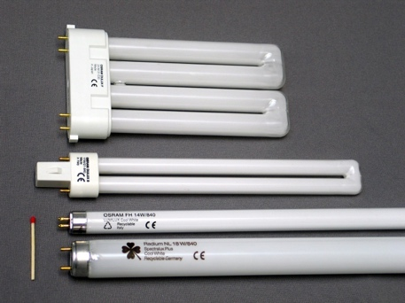Those designed for 12- or 24-volt operation have compact filaments, useful for good optical control. Also, they have higher efficacies (lumens per watt) and better lives than non-halogen types. The light output remains almost constant throughout their life.

**Fluorescent lamp**

[Fluorescent lamps](https://en.wikipedia.org/wiki/Fluorescent_lamp) consist of a glass tube that contains mercury vapour or argon under low pressure. Electricity flowing through the tube causes the gases to give off ultraviolet energy. The inside of the tubes are coated with [phosphors](https://en.wikipedia.org/wiki/Phosphor) that give off visible light when struck by ultraviolet [photons](https://en.wikipedia.org/wiki/Photon).[[7]](https://en.wikipedia.org/wiki/Electric_light#cite_note-7) They have much higher efficiency than incandescent lamps. For the same amount of light generated, they typically use around one-quarter to one-third the power of an incandescent. The typical [luminous efficacy](https://en.wikipedia.org/wiki/Luminous_efficacy) of fluorescent lighting systems is 50–100 lumens per watt, several times the efficacy of incandescent bulbs with comparable light output. Fluorescent lamp fixtures are more costly than incandescent lamps, because they require a [ballast](https://en.wikipedia.org/wiki/Electrical_ballast) to regulate the [current](https://en.wikipedia.org/wiki/Electric_current) through the lamp, but the lower energy cost typically offsets the higher initial cost. [Compact fluorescent lamps](https://en.wikipedia.org/wiki/Compact_fluorescent_lamp) are available in the same popular sizes as incandescent lamps and are used as an [energy-saving](https://en.wikipedia.org/wiki/Energy_conservation) alternative in homes. Because they contain mercury, many fluorescent lamps are classified as [hazardous waste](https://en.wikipedia.org/wiki/Hazardous_waste). The [United States Environmental Protection Agency](https://en.wikipedia.org/wiki/United_States_Environmental_Protection_Agency) recommends that fluorescent lamps be segregated from general waste for [recycling](https://en.wikipedia.org/wiki/Recycling) or safe disposal, and some jurisdictions require recycling of them.[[8]](https://en.wikipedia.org/wiki/Electric_light#cite_note-8)

### **LED lamp**

The solid-state [light-emitting diode](https://en.wikipedia.org/wiki/Light-emitting_diode) (LED) has been popular as an indicator light in [consumer electronics](https://en.wikipedia.org/wiki/Consumer_electronics) and professional audio gear since the 1970s. In the 2000s, efficacy and output have risen to the point where LEDs are now being used in lighting applications such as car headlights and brake lights, in flashlights and bicycle lights, as well as in decorative applications, such as holiday lighting. Indicator LEDs are known for their extremely long life, up to 100,000 hours, but lighting LEDs are operated much less conservatively, and consequently have shorter lives. LED technology is useful for lighting designers, because of its low power consumption, low heat generation, instantaneous on/off control, and in the case of single color LEDs, continuity of color throughout the life of the diode and relatively low cost of manufacture. LED lifetime depends strongly on the temperature of the diode. Operating an LED lamp in conditions that increase the internal temperature can greatly shorten the lamp's life.

**Carbon arc lamp**

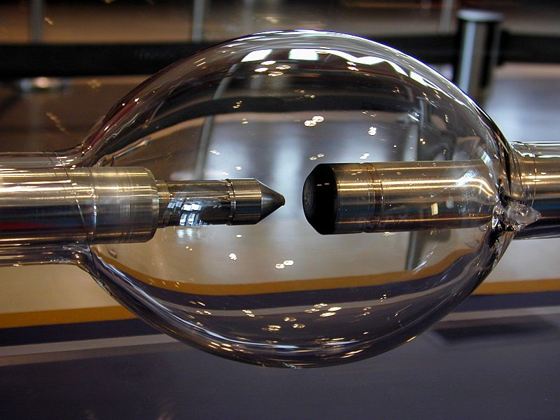Carbon arc lamps consist of two carbon rod [electrodes](https://en.wikipedia.org/wiki/Electrode) in open air, supplied by a current-limiting [ballast](https://en.wikipedia.org/wiki/Electrical_ballast). The [electric arc](https://en.wikipedia.org/wiki/Electric_arc) is struck by touching the rod tips then separating them. The ensuing arc produces a white-hot [plasma](https://en.wikipedia.org/wiki/Plasma_(physics)) between the rod tips. These lamps have higher efficacy than filament lamps, but the carbon rods are short-lived and require constant adjustment in use, as the intense heat of the arc erodes them. The lamps produce significant [ultraviolet](https://en.wikipedia.org/wiki/Ultraviolet) o

utput, they require ventilation when used indoors, and due to their intensity they need protection from direct sight.

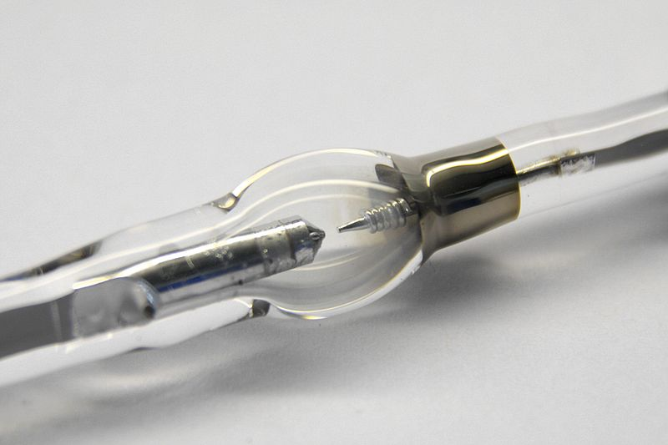Invented by [Humphry Davy](https://en.wikipedia.org/wiki/Humphry_Davy) around 1805, the carbon arc was the first practical electric light. It was used commercially beginning in the 1870s for large building and street lighting until it was superseded in the early 20th century by the incandescent light. Carbon arc lamps operate at high power and produce high intensity white light. They also are a point source of light. They remained in use in limited applications that required these properties, such as [movie projectors](https://en.wikipedia.org/wiki/Movie_projector), [stage lighting](https://en.wikipedia.org/wiki/Stage_lighting), and [searchlights](https://en.wikipedia.org/wiki/Searchlight), until after World War II.

### **Discharge lamp**

A discharge lamp has a glass or silica envelope containing two metal [electrodes](https://en.wikipedia.org/wiki/Electrode) separated by a gas. Gases used include, [neon](https://en.wikipedia.org/wiki/Neon), [argon](https://en.wikipedia.org/wiki/Argon), [xenon](https://en.wikipedia.org/wiki/Xenon), [sodium](https://en.wikipedia.org/wiki/Sodium), [metal halide](https://en.wikipedia.org/wiki/Metal_halides), and [mercury](https://en.wikipedia.org/wiki/Mercury_(element)). The core operating principle is much the same as the carbon arc lamp, but the term "arc lamp" normally refers to carbon arc lamps, with more modern types of gas discharge lamp normally called discharge lamps. With some discharge lamps, very high voltage is used to strike the arc. This requires an electrical circuit called an igniter, which is part of the [electrical ballast](https://en.wikipedia.org/wiki/Electrical_ballast) circuitry. After the arc is struck, the internal resistance of the lamp drops to a low level, and the ballast limits the current to the operating current. Without a ballast, excess current would flow, causing rapid destruction of the lamp.

Some lamp types contain a little neon, which permits striking at normal running voltage, with no external ignition circuitry. [Low pressure sodium lamps](https://en.wikipedia.org/wiki/Sodium-vapor_lamp) operate this way. The simplest ballasts are just an inductor, and are chosen where cost is the deciding factor, such as street lighting. More advanced electronic ballasts may be designed to maintain constant light output over the life of the lamp, may drive the lamp with a square wave to maintain completely flicker-free output, and shut down in the event of certain faults.

### **Form factors**

Many lamp units, or light bulbs, are specified in standardized shape codes and socket names. Incandescent bulbs and their retrofit replacements are often specified as "[A19](https://en.wikipedia.org/wiki/A-series_light_bulb)/A60 [E26](https://en.wikipedia.org/wiki/Edison_screw)/E27", a common size for these kind of light bulbs. In this example, the "A" parameters describe the bulb size and shape while the "E" parameters describe the Edison screw base size and thread characteristics.

### **Lamp life expectancy**

Life expectancy for many types of lamp is defined as the number of hours of operation at which 50% of them fail, that is the [median](https://en.wikipedia.org/wiki/Median) life of the lamps. Production tolerances as low as 1% can create a variance of 25% in lamp life, so in general some lamps will fail well before the rated life expectancy, and some will last much longer. For LEDs, lamp life is defined as the operation time at which 50% of lamps have experienced a 70% decrease in light output.

Some types of lamp are also sensitive to switching cycles. Rooms with frequent switching, such as bathrooms, can expect much shorter lamp life than what is printed on the box. Compact fluorescent lamps are particularly sensitive to switching cycles.

|  |  |  |  |  |  |  |
| --- | --- | --- | --- | --- | --- | --- |
| **Name** | [**Optical spectrum**](https://en.wikipedia.org/wiki/Visible_spectrum) | **Nominal**[**efficacy**](https://en.wikipedia.org/wiki/Luminous_efficacy) **([lm](https://en.wikipedia.org/wiki/Lumen_(unit)" \o "Lumen (unit))/**[**W**](https://en.wikipedia.org/wiki/Watt)**)** | **Lifetime (**[**MTTF**](https://en.wikipedia.org/wiki/Mean_time_between_failures)**) (hours)** | [**Color temperature**](https://en.wikipedia.org/wiki/Color_temperature) **(**[**kelvin**](https://en.wikipedia.org/wiki/Kelvin)**)** | [**Color**](https://en.wikipedia.org/wiki/Color) | [**Color rendering index**](https://en.wikipedia.org/wiki/Color_rendering_index) |
| [Incandescent light bulb](https://en.wikipedia.org/wiki/Incandescent_light_bulb) | [Continuous](https://en.wikipedia.org/wiki/Continuous_spectrum) | 4–17 | 2–20,000 | 2,400–3,400 | Warm white (yellowish) | 100 |
| [Halogen lamp](https://en.wikipedia.org/wiki/Halogen_lamp) | Continuous | 16–23 | 3,000–6,000 | 3,200 | Warm white (yellowish) | 100 |
| [Fluorescent lamp](https://en.wikipedia.org/wiki/Fluorescent_lamp) | [Mercury](https://en.wikipedia.org/wiki/Mercury_(element)) line + [Phosphor](https://en.wikipedia.org/wiki/Phosphor) | 52–100 (white) | 8,000–20,000 | 2,700–5,000* | White (various color temperatures), as well as saturated colors available | 15–85 |
| [Metal-halide lamp](https://en.wikipedia.org/wiki/Metal-halide_lamp) | Quasi-continuous | 50–115 | 6,000–20,000 | 3,000–4,500 | Cold white | 65–93 |
| [Sulfur lamp](https://en.wikipedia.org/wiki/Sulfur_lamp) | Continuous | 80–110 | 15,000–20,000 | 6,000 | Pale green | 79 |
| [High pressure sodium](https://en.wikipedia.org/wiki/Sodium-vapor_lamp) | Broadband | 55–140 | 10,000–40,000 | 1,800–2,200* | Pinkish orange | 0–70 |
| [Low pressure sodium](https://en.wikipedia.org/wiki/Sodium-vapor_lamp) | Narrow line | 100–200 | 18,000–20,000 | 1,800* | Yellow, no color rendering | 0 |
| [LED lamp](https://en.wikipedia.org/wiki/LED_lamp) | Line plus phosphor | 10–110 (white) | 50,000–100,000 | Various white from 2,700 to 6,000* | Various color temperatures, as well as saturated colors | 70–85 (white) |
| [Electrodeless lamp](https://en.wikipedia.org/wiki/Electrodeless_lamp) | [Mercury](https://en.wikipedia.org/wiki/Mercury_(element)) line + [Phosphor](https://en.wikipedia.org/wiki/Phosphor) | 70–90 (white) | 80,000–100,000 | Various white from 2,700 to 6,000* | Various color temperatures, as well as saturated colors | 70–85 |

**LED Device Structure**

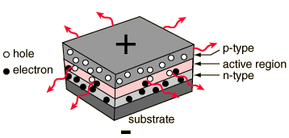

One way to constuct an [LED](http://hyperphysics.phy-astr.gsu.edu/hbase/Electronic/led.html#c1) is to deposit three semiconductor layers on a substrate. Between [p-type](http://hyperphysics.phy-astr.gsu.edu/hbase/solids/dope.html#c4) and [n-type](http://hyperphysics.phy-astr.gsu.edu/hbase/solids/dope.html#c3) semiconductor layers, an active region emits light when an [electron and hole](http://hyperphysics.phy-astr.gsu.edu/hbase/solids/intrin.html#c4) recombine.

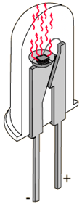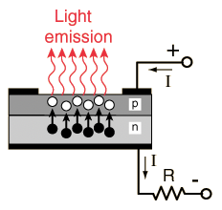Considering the p-n combination to be a diode,then when the diode is [forward biased](http://hyperphysics.phy-astr.gsu.edu/hbase/solids/diod.html#c1), holes from the p-type material and electrons from the n-type material are both driven into the active region. The light is produced by a solid state process called [electroluminescence](http://hyperphysics.phy-astr.gsu.edu/hbase/Electronic/led.html#c2).

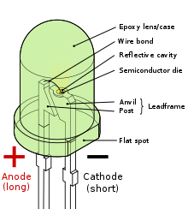LEDs are p-n junction devices constructed of gallium arsenide (GaAs), gallium arsenide phosphide (GaAsP), or gallium phosphide (GaP). Silicon and germanium are not suitable because those junctions produce heat and no appreciable IR or visible light. The junction in a LED is forward biased and when electrons cross the junction from the n- to the p-type material, the electron-hole recombination process produces some photons in the IR or visible in a process called electroluminescence. An exposed semiconductor surface can then emit light.

In this particular design, the layers of the LED emit light all the way around the layered structure, and the LED structure is placed in a tiny reﬂective cup so that the light from the active layer will be reﬂected toward the desired exit direction

### Layers of LED

### A Light Emitting Diode (LED) consists of three layers: [p-type semiconductor](https://www.physics-and-radio-electronics.com/electronic-devices-and-circuits/semiconductor/extrinsic-semiconductor/p-type-semiconductor.html), [n-type semiconductor](https://www.physics-and-radio-electronics.com/electronic-devices-and-circuits/semiconductor/extrinsic-semiconductor/n-type-semiconductor.html) and depletion layer. The p-type semiconductor and the n-type semiconductor are separated by a [depletion region](https://www.physics-and-radio-electronics.com/electronic-devices-and-circuits/semiconductor-diodes/depletion-region.html) or depletion layer.

### P-type semiconductor

### When trivalent impurities are added to the intrinsic or pure semiconductor, a p-type semiconductor is formed.

### In p-type semiconductor, holes are the majority charge carriers and free electrons are the minority charge carriers. Thus, holes carry most of the electric current in p-type semiconductor.

### N-type semiconductor

### When pentavalent impurities are added to the intrinsic semiconductor, an n-type semiconductor is formed.

### In n-type semiconductor, free electrons are the majority charge carriers and holes are the minority charge carriers. Thus, free electrons carry most of the electric current in n-type semiconductor.

### Depletion layer or region

### Depletion region is a region present between the p-type and n-type semiconductor where no mobile charge carriers (free electrons and holes) are present. This region acts as barrier to the electric current. It opposes flow of electrons from n-type semiconductor and flow of holes from p-type semiconductor.

### To overcome the barrier of depletion layer, we need to apply voltage which is greater than the barrier potential of depletion layer.

### If the applied voltage is greater than the barrier potential of the depletion layer, the electric current starts flowing.

**LED Construction**

Light Emitting Diode (LED) works only in forward bias condition. When Light Emitting Diode (LED) is forward biased, the free electrons from n-side and the holes from p-side are pushed towards the junction.

When free electrons reach the junction or depletion region, some of the free electrons recombine with the holes in the positive ions. We know that positive ions have less number of electrons than protons. Therefore, they are ready to accept electrons. Thus, free electrons recombine with holes in the depletion region. In the similar way, holes from p-side recombine with electrons in the depletion region.

Because of the recombination of free electrons and holes in the depletion region, the [width of depletion region](https://www.physics-and-radio-electronics.com/electronic-devices-and-circuits/semiconductor-diodes/widthofdepletionregion.html) decreases. As a result, more charge carriers will cross the [p-n junction](https://www.physics-and-radio-electronics.com/electronic-devices-and-circuits/semiconductor-diodes/p-n-junction-introduction.html).

Some of the charge carriers from p-side and n-side will cross the p-n junction before they recombine in the depletion region. For example, some free electrons from n-type semiconductor cross the p-n junction and recombines with holes in p-type semiconductor. In the similar way, holes from p-type semiconductor cross the p-n junction and recombines with free electrons in the n-type semiconductor.

Thus, recombination takes place in depletion region as well as in p-type and n-type semiconductor.

The free electrons in the conduction band releases energy in the form of light before they recombine with holes in the valence band.

In silicon and germanium diodes, most of the energy is released in the form of heat and emitted light is too small.

However, in materials like gallium arsenide and gallium phosphide the emitted photons have sufficient energy to produce intense visible light.

**LED Characteristics**

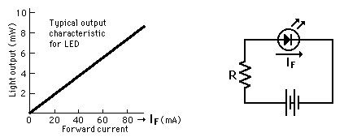

When an LED is forward biased to the threshold of conduction, its current increases rapidly and must be controlled to prevent destruction of the device. The light output is quite linearly proportional to the current within its active region, so the light output can be precisely modulated to send an undistorted signal through a ﬁber optic cable.

### Light Emitting Diode Image 2Polarity of LED

Polarity is an indication of symmetricity of an electronic component. A Light Emitting Diode, similar to a PN Junction Diode, is not symmetric i.e. it allows current to flow only in one direction.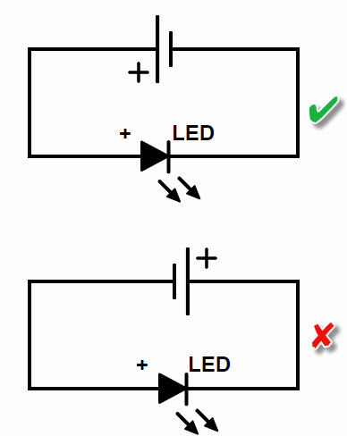In an LED, the positive terminal is called as Anode and the negative terminal is called as Cathode. For the LED to work properly, the Anode of the LED should be at a higher potential than the Cathode as the current in LED flows from Anode to Cathode.What happens if we connect the LED in reverse direction? Well, nothing happens as the LED would not conduct. You can easily identify the Anode terminal of an LED as they usually have longer leads.   
  
Forward Current of LED  
LEDs are very sensitive devices and the amount of current flowing through an LED is very important. Also, the brightness of an LED depends on the amount of current drawn by the LED. Every LED is rated with a maximum forward current that is safe to pass through it without burning off the LED. Yes. Allowing current more than the rated current will actually burn the LED. For example, most commonly used 5mm LEDs have a current rating of 20mA to 30mA and the 8mm LEDs have a current rating of 150mA (refer to the datasheet for exact values). How to we regulate the current flowing through an LED? In order to control the current flowing through an LED, we make use of current limiting series resistors.  
  
Forward Voltage of LED  
Light Emitting Diodes are also rated for forward voltage i.e. the amount of voltage required for the LED to conduct electricity. For example, all 5mm LEDs have a current rating of 20mA but the forward voltage varies one LED to another.  
Red LEDs have a maximum voltage rating of 2.2V, Blue LEDs have a maximum voltage rating of 3.4V and White LEDs have a maximum voltage rating of 3.6V.

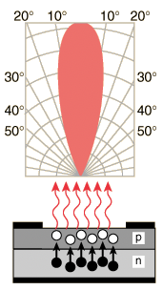**LED Radiation Patterns**

An LED is a directional light source, with the maximum emitted power in the direction perpendicular to the emitting surface. The typical radiation pattern shows that most of the energy is emitted within 20° of the direction of maximum light. Some packages for LEDs include plastic lenses to spread the light for a greater angle of visibility.

In a light emitting diode, the recombination of electrons and electron holes in a semiconductor produces light (or infrared radiation), a process called "[electroluminescence](https://en.wikipedia.org/wiki/Electroluminescence)". The wavelength of the light depends on the energy [band gap](https://en.wikipedia.org/wiki/Band_gap) of the semiconductors used. Since these materials have a high index of refraction, design features of the devices such as special optical coatings and die shape are required to efficiently emit light.

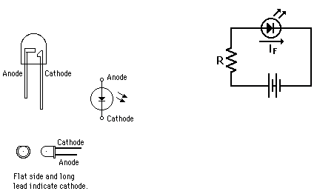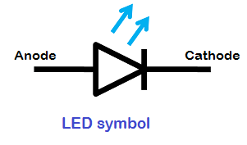**Light Emitting Diodes Diagrams**

**Electroluminescence in LEDs**

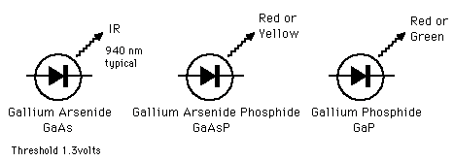When the applied forward voltage on the diode of the LED drives the electrons and holes into the active region between the n-type and p-type material, the energy can be converted into infrared or visible photons. This implies that the electron-hole pair drops into a more stable bound state, releasing energy on the order of electron volts by emission of a photon. The red extreme of the visible spectrum, 700 nm, requires an energy release of 1.77 eV to provide the quantum energy of the photon. At the other extreme, 400 nm in the violet, 3.1 eV is required.

**Blue LED**

After a decade of intense research, a bright blue LED was successfully produced by Nichia Chemical of Japan in 1994. The material used for the diode was gallium nitride GaN. Nichia has also produced an InGaN laser diode which lases in the blue-violet region of the spectrum.

Blue LEDs are important for the development of high-information-density storage on optical disks, as well as a host of other applications such as high-resolution television and computer displays, image scanners and color printers, biomedical diagnostic instruments, and remote sensing.

Other ways of producing blue light from solid state sources involve doubling the frequency of red or infrared laser diodes. Hitachi and Matsushita have taken this approach to producing blue light for optical disks and digital versatile disks (DVD).

Blue LEDs have an active region consisting of one or more InGaN [quantum wells](https://en.wikipedia.org/wiki/Quantum_well) sandwiched between thicker layers of GaN, called cladding layers. By varying the relative In/Ga fraction in the InGaN quantum wells, the light emission can in theory be varied from violet to amber.

[Aluminium gallium nitride](https://en.wikipedia.org/wiki/Aluminium_gallium_nitride) (AlGaN) of varying Al/Ga fraction can be used to manufacture the cladding and quantum well layers for ultraviolet LEDs, but these devices have not yet reached the level of efficiency and technological maturity of InGaN/GaN blue/green devices. If un-alloyed GaN is used in this case to form the active quantum well layers, the device emits near-ultraviolet light with a peak wavelength centred around 365 nm. Green LEDs manufactured from the InGaN/GaN system are far more efficient and brighter than green LEDs produced with non-nitride material systems, but practical devices still exhibit efficiency too low for high-brightness applications.[[citation needed](https://en.wikipedia.org/wiki/Wikipedia:Citation_needed)]

With [AlGaN](https://en.wikipedia.org/wiki/Aluminium_gallium_nitride" \o "Aluminium gallium nitride) and [AlGaInN](https://en.wikipedia.org/w/index.php?title=Aluminium_gallium_indium_nitride&action=edit&redlink=1" \o "Aluminium gallium indium nitride (page does not exist)), even shorter wavelengths are achievable. Near-UV emitters at wavelengths around 360–395 nm are already cheap and often encountered, for example, as [black light](https://en.wikipedia.org/wiki/Black_light) lamp replacements for inspection of anti-[counterfeiting](https://en.wikipedia.org/wiki/Counterfeiting) UV watermarks in documents and bank notes, and for [UV curing](https://en.wikipedia.org/wiki/UV_curing#LEDs). While substantially more expensive, shorter-wavelength diodes are commercially available for wavelengths down to 240 nm. As the photosensitivity of microorganisms approximately matches the absorption spectrum of [DNA](https://en.wikipedia.org/wiki/DNA), with a peak at about 260 nm, UV LED emitting at 250–270 nm are expected in prospective disinfection and sterilization devices. Recent research has shown that commercially available UVA LEDs (365 nm) are already effective disinfection and sterilization devices. UV-C wavelengths were obtained in laboratories using [aluminium nitride](https://en.wikipedia.org/wiki/Aluminium_nitride) (210 nm), [boron nitride](https://en.wikipedia.org/wiki/Boron_nitride) (215 nm) and [diamond](https://en.wikipedia.org/wiki/Diamond) (235 nm).

The first blue-violet LED using magnesium-doped [gallium nitride](https://en.wikipedia.org/wiki/Gallium_nitride) was made at [Stanford University](https://en.wikipedia.org/wiki/Stanford_University) in 1972 by Herb Maruska and Wally Rhines, doctoral students in materials science and engineering. At the time Maruska was on leave from [RCA Laboratories](https://en.wikipedia.org/wiki/RCA), where he collaborated with Jacques Pankove on related work. In 1971, the year after Maruska left for Stanford, his RCA colleagues Pankove and Ed Miller demonstrated the first blue electroluminescence from zinc-doped gallium nitride, though the subsequent device Pankove and Miller built, the first actual gallium nitride light-emitting diode, emitted green light. In 1974 the [U.S. Patent Office](https://en.wikipedia.org/wiki/U.S._Patent_Office) awarded Maruska, Rhines and Stanford professor David Stevenson a patent for their work in 1972. Today, magnesium-doping of gallium nitride remains the basis for all commercial blue LEDs and [laser diodes](https://en.wikipedia.org/wiki/Laser_diode). In the early 1970s, these devices were too dim for practical use, and research into gallium nitride devices slowed.

In August 1989, [Cree](https://en.wikipedia.org/wiki/Cree_Inc.) introduced the first commercially available blue LED based on the [indirect bandgap](https://en.wikipedia.org/wiki/Direct_and_indirect_band_gaps) semiconductor, silicon carbide (SiC). SiC LEDs had very low efficiency, no more than about 0.03%, but did emit in the blue portion of the visible light spectrum.

In the late 1980s, key breakthroughs in GaN [epitaxial](https://en.wikipedia.org/wiki/Epitaxial) growth and [p-type](https://en.wikipedia.org/wiki/P-type_semiconductor) doping ushered in the modern era of GaN-based optoelectronic devices. Building upon this foundation, Theodore Moustakas at Boston University patented a method for producing high-brightness blue LEDs using a new two-step process in 1991.

Two years later, in 1993, high-brightness blue LEDs were demonstrated by [Shuji Nakamura](https://en.wikipedia.org/wiki/Shuji_Nakamura) of [Nichia Corporation](https://en.wikipedia.org/wiki/Nichia_Corporation) using a gallium nitride growth process. In parallel, [Isamu Akasaki](https://en.wikipedia.org/wiki/Isamu_Akasaki) and [Hiroshi Amano](https://en.wikipedia.org/wiki/Hiroshi_Amano) in [Nagoya](https://en.wikipedia.org/wiki/Nagoya) were working on developing the important [GaN](https://en.wikipedia.org/wiki/Gallium_nitride" \o "Gallium nitride) deposition on sapphire substrates and the demonstration of [p-type doping](https://en.wikipedia.org/wiki/P-type_semiconductor) of GaN. This new development revolutionized LED lighting, making [high-power blue light sources](https://en.wikipedia.org/wiki/Blue_laser) practical, leading to the development of technologies like [Blu-ray](https://en.wikipedia.org/wiki/Blu-ray)[[citation needed](https://en.wikipedia.org/wiki/Wikipedia:Citation_needed)].

Nakamura was awarded the 2006 [Millennium Technology Prize](https://en.wikipedia.org/wiki/Millennium_Technology_Prize) for his invention. Nakamura, [Hiroshi Amano](https://en.wikipedia.org/wiki/Hiroshi_Amano) and [Isamu Akasaki](https://en.wikipedia.org/wiki/Isamu_Akasaki) were awarded the [Nobel Prize in Physics](https://en.wikipedia.org/wiki/Nobel_Prize_in_Physics) in 2014 for the invention of the blue LED. In 2015, a US court ruled that three companies had infringed Moustakas's prior patent, and ordered them to pay licensing fees of not less than US$13 million.

In 1995, [Alberto Barbieri](https://en.wikipedia.org/wiki/Alberto_Barbieri) at the [Cardiff University](https://en.wikipedia.org/wiki/Cardiff_University) Laboratory (GB) investigated the efficiency and reliability of high-brightness LEDs and demonstrated a "transparent contact" LED using [indium tin oxide](https://en.wikipedia.org/wiki/Indium_tin_oxide) (ITO) on (AlGaInP/GaAs).

In 2001 and 2002, processes for growing [gallium nitride](https://en.wikipedia.org/wiki/Gallium_nitride) (GaN) LEDs on [silicon](https://en.wikipedia.org/wiki/Silicon) were successfully demonstrated. In January 2012, [Osram](https://en.wikipedia.org/wiki/Osram) demonstrated high-power InGaN LEDs grown on silicon substrates commercially, and GaN-on-silicon LEDs are in production at [Plessey Semiconductors](https://en.wikipedia.org/wiki/Plessey#Plessey_Semiconductors_Ltd). As of 2017, some manufacturers are using SiC as the substrate for LED production, but sapphire is more common, as it has the most similar properties to that of gallium nitride, reducing the need for patterning the sapphire wafer (patterned wafers are known as epi wafers). [Samsung](https://en.wikipedia.org/wiki/Samsung), the [University of Cambridge](https://en.wikipedia.org/wiki/University_of_Cambridge), and [Toshiba](https://en.wikipedia.org/wiki/Toshiba) are performing research into GaN on Si LEDs. Toshiba has stopped research, possibly due to low yields. Some opt towards epitaxy, which is difficult on [silicon](https://en.wikipedia.org/wiki/Silicon), while others, like the University of Cambridge, opt towards a multi-layer structure, in order to reduce (crystal) lattice mismatch and different thermal expansion ratios, in order to avoid cracking of the LED chip at high temperatures (e.g. during manufacturing), reduce heat generation and increase luminous efficiency. Epitaxy (or patterned sapphire) can be carried out with [nanoimprint lithography](https://en.wikipedia.org/wiki/Nanoimprint_lithography). GaN is often deposited using [Metalorganic vapour-phase epitaxy](https://en.wikipedia.org/wiki/Metalorganic_vapour-phase_epitaxy) (MOCVD).

**White LEDs**

There are two primary ways of producing [white](https://en.wikipedia.org/wiki/White) light-emitting diodes. One is to use individual LEDs that emit three [primary colors](https://en.wikipedia.org/wiki/Primary_color)—red, green and blue—and then mix all the colors to form white light. The other is to use a phosphor material to convert monochromatic light from a blue or UV LED to broad-spectrum white light, similar to a [fluorescent lamp](https://en.wikipedia.org/wiki/Fluorescent_lamp). The yellow phosphor is [cerium](https://en.wikipedia.org/wiki/Cerium)-doped [YAG](https://en.wikipedia.org/wiki/YAG) crystals suspended in the package or coated on the LED. This YAG phosphor causes white LEDs to look yellow when off.

The 'whiteness' of the light produced is engineered to suit the human eye. Because of [metamerism](https://en.wikipedia.org/wiki/Metamerism_(color)), it is possible to have quite different spectra that appear white. However, the appearance of objects illuminated by that light may vary as the spectrum varies. This is the issue of color rendition, quite separate from color temperature. An orange or cyan object could appear with the wrong color and much darker as the LED or phosphor does not emit the wavelength it reflects. The best color rendition LEDs use a mix of phosphors, resulting in less efficiency but better color rendering.

Another method used to produce experimental white light LEDs used no phosphors at all and was based on [homoepitaxially](https://en.wikipedia.org/wiki/Epitaxy) grown [zinc selenide](https://en.wikipedia.org/wiki/Zinc_selenide) (ZnSe) on a ZnSe substrate that simultaneously emitted blue light from its active region and yellow light from the substrate.

A new style of wafers composed of gallium-nitride-on-silicon (GaN-on-Si) is being used to produce white LEDs using 200-mm silicon wafers. This avoids the typical costly [sapphire](https://en.wikipedia.org/wiki/Sapphire) [substrate](https://en.wikipedia.org/wiki/Substrate_(materials_science)) in relatively small 100- or 150-mm wafer sizes.[[101]](https://en.wikipedia.org/wiki/Light-emitting_diode#cite_note-electronicdesign.com-101) The sapphire apparatus must be coupled with a mirror-like collector to reflect light that would otherwise be wasted. It is predicted that by 2020, 40% of all GaN LEDs will be made with GaN-on-Si. Manufacturing large sapphire material is difficult, while large silicon material is cheaper and more abundant. LED companies shifting from using sapphire to silicon should be a minimal investment.

Even though white light can be created using individual red, green and blue LEDs, this results in poor color rendering, since only three narrow bands of wavelengths of light are being emitted. The attainment of high efficiency blue LEDs was quickly followed by the development of the first [white LED](https://en.wikipedia.org/wiki/Light-emitting_diode#Phosphor-based_LEDs). In this device a Y3Al5O12:Ce (known as "[YAG](https://en.wikipedia.org/wiki/YAG)" or Ce:YAG phosphor) [cerium](https://en.wikipedia.org/wiki/Cerium) doped phosphor coating produces yellow light through [fluorescence](https://en.wikipedia.org/wiki/Fluorescence). The combination of that yellow with remaining blue light appears white to the eye. Using different [phosphors](https://en.wikipedia.org/wiki/Phosphor) produces green and red light through fluorescence. The resulting mixture of red, green and blue is perceived as white light, with improved [color rendering](https://en.wikipedia.org/wiki/Color_rendering) compared to wavelengths from the blue LED/YAG phosphor combination.

The first white LEDs were expensive and inefficient. However, the light output of LEDs has increased [exponentially](https://en.wikipedia.org/wiki/Exponential_growth). The latest research and development has been propagated by Japanese manufacturers such as [Panasonic](https://en.wikipedia.org/wiki/Panasonic), and [Nichia](https://en.wikipedia.org/wiki/Nichia), and by Korean and Chinese manufacturers such as [Samsung](https://en.wikipedia.org/wiki/Samsung), Kingsun, and others. This trend in increased output has been called [Haitz's law](https://en.wikipedia.org/wiki/Haitz%27s_law" \o "Haitz's law) after Dr. Roland Haitz.

Light output and efficiency of blue and near-ultraviolet LEDs rose and the cost of reliable devices fell. This led to relatively high-power white-light LEDs for illumination, which are replacing incandescent and fluorescent lighting. Experimental white LEDs have been demonstrated to produce 303 lumens per watt of electricity (lm/w); some can last up to 100,000 hours. However, commercially available LEDs have an efficiency of up to 223 lm/w. Compared to incandescent bulbs, this is not only a huge increase in electrical efficiency, and even though the bulbs are more expensive to purchase, significantly cheaper overall cost per bulb.

**RGB LEDs**

Mixing red, green, and blue sources to produce white light needs electronic circuits to control the blending of the colors. Since LEDs have slightly different emission patterns, the color balance may change depending on the angle of view, even if the RGB sources are in a single package, so RGB diodes are seldom used to produce white lighting. Nonetheless, this method has many applications because of the flexibility of mixing different colors, and in principle, this mechanism also has higher quantum efficiency in producing white light.

There are several types of multicolor white LEDs: [di-](https://en.wiktionary.org/wiki/dichromatic), [tri-](https://en.wikipedia.org/wiki/Trichromatic), and [tetrachromatic](https://en.wikipedia.org/wiki/Tetrachromatic) white LEDs. Several key factors that play among these different methods include color stability, [color rendering](https://en.wikipedia.org/wiki/Color_rendering_index) capability, and luminous efficacy. Often, higher efficiency means lower color rendering, presenting a trade-off between the luminous efficacy and color rendering. For example, the dichromatic white LEDs have the best luminous efficacy (120 lm/W), but the lowest color rendering capability. However, although tetrachromatic white LEDs have excellent color rendering capability, they often have poor luminous efficacy. Trichromatic white LEDs are in between, having both good luminous efficacy (>70 lm/W) and fair color rendering capability.

One of the challenges is the development of more efficient green LEDs. The theoretical maximum for green LEDs is 683 lumens per watt but as of 2010 few green LEDs exceed even 100 lumens per watt. The blue and red LEDs approach their theoretical limits.

Multicolor LEDs also offer a new means to form light of different colors. Most [perceivable colors](https://en.wikipedia.org/wiki/Color#Perception) can be formed by mixing different amounts of three primary colors. This allows precise dynamic color control. However, this type of LED's emission power [decays exponentially](https://en.wikipedia.org/wiki/Exponential_decay) with rising temperature, resulting in a substantial change in color stability. Such problems inhibit industrial use. Multicolor LEDs without phosphors cannot provide good color rendering because each LED is a narrowband source. LEDs without phosphor, while a poorer solution for general lighting, are the best solution for displays, either backlight of LCD, or direct LED based pixels.

Dimming a multicolor LED source to match the characteristics of incandescent lamps is difficult because manufacturing variations, age, and temperature change the actual color value output. To emulate the appearance of dimming incandescent lamps may require a feedback system with color sensor to actively monitor and control the color

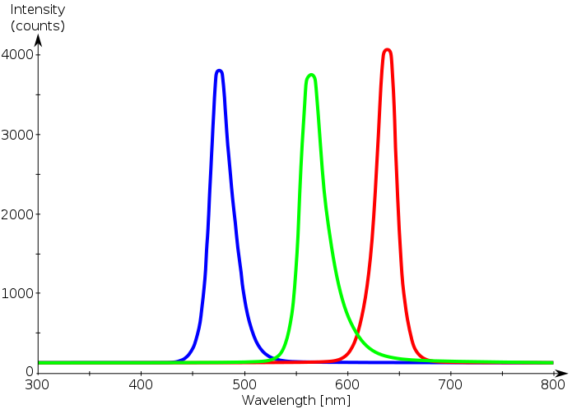

#### **Phosphor-based LEDs**

Phosphor-based LEDs have efficiency losses due to heat loss from the [Stokes shift](https://en.wikipedia.org/wiki/Stokes_shift) and also other phosphor-related issues. Their luminous efficacies compared to normal LEDs depend on the spectral distribution of the resultant light output and the original wavelength of the LED itself. For example, the luminous efficacy of a typical YAG yellow phosphor based white LED ranges from 3 to 5 times the luminous efficacy of the original blue LED because of the human eye's greater sensitivity to yellow than to blue (as modeled in the [luminosity function](https://en.wikipedia.org/wiki/Luminosity_function)). Due to the simplicity of manufacturing, the phosphor method is still the most popular method for making high-intensity white LEDs. The design and production of a light source or light fixture using a monochrome emitter with phosphor conversion is simpler and cheaper than a complex [RGB](https://en.wikipedia.org/wiki/Light-emitting_diode#RGB_systems) system, and the majority of high-intensity white LEDs presently on the market are manufactured using phosphor light conversion.

Among the challenges being faced to improve the efficiency of LED-based white light sources is the development of more efficient phosphors. As of 2010, the most efficient yellow phosphor is still the YAG phosphor, with less than 10% Stokes shift loss. Losses attributable to internal optical losses due to re-absorption in the LED chip and in the LED packaging itself account typically for another 10% to 30% of efficiency loss. Currently, in the area of phosphor LED development, much effort is being spent on optimizing these devices to higher light output and higher operation temperatures. For instance, the efficiency can be raised by adapting better package design or by using a more suitable type of phosphor. Conformal coating process is frequently used to address the issue of varying phosphor thickness.

Some phosphor-based white LEDs encapsulate InGaN blue LEDs inside phosphor-coated epoxy. Alternatively, the LED might be paired with a remote phosphor, a preformed polycarbonate piece coated with the phosphor material. Remote phosphors provide more diffuse light, which is desirable for many applications. Remote phosphor designs are also more tolerant of variations in the LED emissions spectrum. A common yellow phosphor material is [cerium](https://en.wikipedia.org/wiki/Cerium)-[doped](https://en.wikipedia.org/wiki/Doping_(Semiconductors)) [yttrium aluminium garnet](https://en.wikipedia.org/wiki/Yttrium_aluminium_garnet) (Ce3+:YAG).

White LEDs can also be made by [coating](https://en.wikipedia.org/wiki/Coating) near-[ultraviolet](https://en.wikipedia.org/wiki/Ultraviolet) (NUV) LEDs with a mixture of high-efficiency [europium](https://en.wikipedia.org/wiki/Europium)-based phosphors that emit red and blue, plus copper and aluminium-doped zinc sulfide (ZnS:Cu, Al) that emits green. This is a method analogous to the way [fluorescent lamps](https://en.wikipedia.org/wiki/Fluorescent_lamp) work. This method is less efficient than blue LEDs with YAG:Ce phosphor, as the Stokes shift is larger, so more energy is converted to heat, but yields light with better spectral characteristics, which render color better. Due to the higher radiative output of the ultraviolet LEDs than of the blue ones, both methods offer comparable brightness. A concern is that UV light may leak from a malfunctioning light source and cause harm to human eyes or skin.

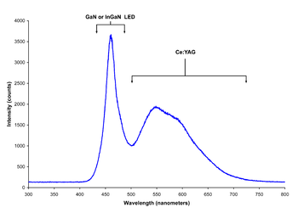

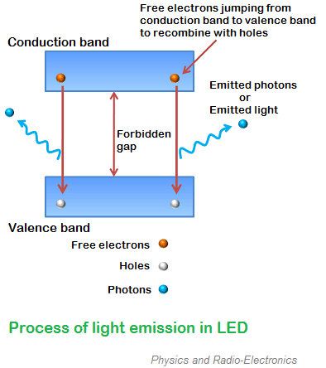**LED Emitting Light**

When external voltage is applied to the [valence electrons](https://www.physics-and-radio-electronics.com/electronic-devices-and-circuits/introduction/valence-electrons.html), they gain sufficient energy and breaks the bonding with the parent atom. The valence electrons which breaks bonding with the parent atom are called free electrons.

When the valence electron left the parent atom, they leave an empty space in the valence shell at which valence electron left. This empty space in the valence shell is called a hole.

The energy level of all the valence electrons is almost same. Grouping the range of energy levels of all the valence electrons is called valence band.

In the similar way, energy level of all the free electrons is almost same. Grouping the range of energy levels of all the free electrons is called conduction band.

The energy level of free electrons in the conduction band is high compared to the energy level of valence electrons or holes in the valence band. Therefore, free electrons in the conduction band need to lose energy in order to recombine with the holes in the valence band.

The free electrons in the conduction band do not stay for long period. After a short period, the free electrons lose energy in the form of light and recombine with the holes in the valence band. Each recombination of charge carrier will emit some light energy.

The energy lose of free electrons or the intensity of emitted light is depends on the forbidden gap or energy gap between conduction band and valence band.

The semiconductor device with large forbidden gap emits high intensity light whereas the semiconductor device with small forbidden gap emits low intensity light.

In other words, the brightness of the emitted light is depends on the material used for constructing LED and forward current flow through the LED.

In normal silicon diodes, the energy gap between conduction band and valence band is less. Hence, the electrons fall only a short distance. As a result, low energy photons are released. These low energy photons have low frequency which is invisible to human eye.

In LEDs, the energy gap between conduction band and valence band is very large so the free electrons in LEDs have greater energy than the free electrons in silicon diodes. Hence, the free electrons fall to a large distance. As a result, high energy photons are released. These high energy photons have high frequency which is visible to human eye.

The efficiency of generation of light in LED increases with increase in injected current and with a decrease in temperature.

In light emitting diodes, light is produced due to recombination process. Recombination of charge carriers takes place only under forward bias condition. Hence, LEDs operate only in forward bias condition.

When light emitting diode is reverse biased, the free electrons (majority carriers) from n-side and holes (majority carriers) from p-side moves away from the junction. As a result, the width of depletion region increases and no recombination of charge carriers occur. Thus, no light is produced.

If the reverse bias voltage applied to the LED is highly increased, the device may also be damaged.

All diodes emit photons or light but not all diodes emit visible light. The material in an LED is selected in such a way that the wavelength of the released photons falls within the visible portion of the light spectrum.

Light emitting diodes can be switched ON and OFF at a very fast speed of 1 ns.

**Biasing of LED**

The safe forward voltage ratings of most LEDs is from 1V to 3 V and forward current ratings is from 200 mA to 100 mA.

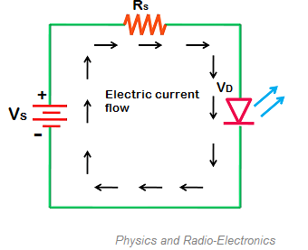If the voltage applied to LED is in between 1V to 3V, LED works perfectly because the current flow for the applied voltage is in the operating range. However, if the voltage applied to LED is increased to a value greater than 3 volts. The depletion region in the LED breaks down and the electric current suddenly rises. This sudden rise in current may destroy the device.

To avoid this we need to place a [resistor](https://www.physics-and-radio-electronics.com/electronic-devices-and-circuits/passive-components/resistors/resistors.html)(Rs) in series with the LED. The resistor (Rs ) must be placed in between voltage source (Vs) and LED.

The resistor placed between LED and voltage source is called current limiting resistor. This resistor restricts extra current which may destroy the LED. Thus, current limiting resistor protects LED from damage.

The current flowing through the LED is mathematically written as

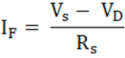

           Where,

                        IF = Forward current

                       VS = Source voltage or supply voltage

                       VD = Voltage drop across LED

                        RS = Resistor or current limiting resistor

Voltage drop is the amount of voltage wasted to overcome the depletion region barrier (which leads to electric current flow).

The voltage drop of LED is 2 to 3V whereas silicon or germanium diode is 0.3 or 0.7 V. Therefore, to operate LED we need to apply greater voltage than silicon or germanium diodes. Light emitting diodes consume more energy than silicon or germanium diodes to operate.

**LED Color**

LEDs are mainly classified into two types: visible LEDs and invisible LEDs. Visible LED is a type of LED that emits visible light. These LEDs are mainly used for display or illumination where LEDs are used individually without photosensors. Invisible LED is a type of LED that emits invisible light (infrared light). These LEDs are mainly used with photosensors such as photodiodes. The material used for constructing LED determines its color. In other words, the wavelength or color of the emitted light depends on the forbidden gap or energy gap of the material. Different materials emit different colors of light.

Gallium arsenide LEDs emit red and infrared light.

Gallium nitride LEDs emit bright blue light.

Yttrium aluminium garnet LEDs emit white light.

Gallium phosphide LEDs emit red, yellow and green light.

Aluminium gallium nitride LEDs emit ultraviolet light.

Aluminum gallium phosphide LEDs emit green light.

## **Advantages of LED**

1. The brightness of light emitted by LED is depends on the current flowing through the LED. Hence, the brightness of LED can be easily controlled by varying the current. This makes possible to operate LED displays under different ambient lighting conditions.
2. Light emitting diodes consume low energy.
3. LEDs are very cheap and readily available.
4. LEDs are light in weight.
5. Smaller size.
6. LEDs have longer lifetime.
7. LEDs operates very fast. They can be turned on and off in very less time.
8. LEDs do not contain toxic material like mercury which is used in fluorescent lamps.
9. LEDs can emit different colors of light.
10. Efficiency: LEDs emit more lumens per watt than incandescent light bulbs.[[127]](https://en.wikipedia.org/wiki/Light-emitting_diode#cite_note-127) The efficiency of LED lighting fixtures is not affected by shape and size, unlike fluorescent light bulbs or tubes.
11. Color: LEDs can emit light of an intended color without using any color filters as traditional lighting methods need. This is more efficient and can lower initial costs.
12. Size: LEDs can be very small (smaller than 2 mm2[[128]](https://en.wikipedia.org/wiki/Light-emitting_diode#cite_note-128)) and are easily attached to printed circuit boards.
13. Warmup time: LEDs light up very quickly. A typical red indicator LED achieves full brightness in under a [microsecond](https://en.wikipedia.org/wiki/Microsecond).[[129]](https://en.wikipedia.org/wiki/Light-emitting_diode#cite_note-129) LEDs used in communications devices can have even faster response times.
14. Cycling: LEDs are ideal for uses subject to frequent on-off cycling, unlike incandescent and fluorescent lamps that fail faster when cycled often, or [high-intensity discharge lamps](https://en.wikipedia.org/wiki/High-intensity_discharge_lamp) (HID lamps) that require a long time before restarting.
15. Dimming: LEDs can very easily be [dimmed](https://en.wikipedia.org/wiki/Dimmer) either by [pulse-width modulation](https://en.wikipedia.org/wiki/Pulse-width_modulation) or lowering the forward current.[[130]](https://en.wikipedia.org/wiki/Light-emitting_diode#cite_note-130) This pulse-width modulation is why LED lights, particularly headlights on cars, when viewed on camera or by some people, seem to flash or flicker. This is a type of [stroboscopic effect](https://en.wikipedia.org/wiki/Stroboscopic_effect).
16. Cool light: In contrast to most light sources, LEDs radiate very little heat in the form of [IR](https://en.wikipedia.org/wiki/Infrared) that can cause damage to sensitive objects or fabrics. Wasted energy is dispersed as heat through the base of the LED.
17. Slow failure: LEDs mainly fail by dimming over time, rather than the abrupt failure of incandescent bulbs.[[131]](https://en.wikipedia.org/wiki/Light-emitting_diode#cite_note-eere-131)
18. Lifetime: LEDs can have a relatively long useful life. One report estimates 35,000 to 50,000 hours of useful life, though time to complete failure may be shorter or longer.[[132]](https://en.wikipedia.org/wiki/Light-emitting_diode#cite_note-132) Fluorescent tubes typically are rated at about 10,000 to 25,000 hours, depending partly on the conditions of use, and incandescent light bulbs at 1,000 to 2,000 hours. Several [DOE](https://en.wikipedia.org/wiki/United_States_Department_of_Energy) demonstrations have shown that reduced maintenance costs from this extended lifetime, rather than energy savings, is the primary factor in determining the payback period for an LED product.[[133]](https://en.wikipedia.org/wiki/Light-emitting_diode#cite_note-133)
19. Shock resistance: LEDs, being solid-state components, are difficult to damage with external shock, unlike fluorescent and incandescent bulbs, which are fragile.[[134]](https://en.wikipedia.org/wiki/Light-emitting_diode#cite_note-134)
20. Focus: The solid package of the LED can be designed to [focus](https://en.wikipedia.org/wiki/Focus_(optics)) its light. Incandescent and fluorescent sources often require an external reflector to collect light and direct it in a usable manner. For larger LED packages [total internal reflection](https://en.wikipedia.org/wiki/Total_internal_reflection) (TIR) lenses are often used to the same effect. However, when large quantities of light are needed many light sources are usually deployed, which are difficult to focus or [collimate](https://en.wikipedia.org/wiki/Collimate) towards the same target.

**Disadvantages of LED**

1. LEDs need more power to operate than normal p-n junction diodes.
2. Luminous efficiency of LEDs is low.
3. Temperature dependence: LED performance largely depends on the ambient temperature of the operating environment – or thermal management properties. Overdriving an LED in high ambient temperatures may result in overheating the LED package, eventually leading to device failure. An adequate [heat sink](https://en.wikipedia.org/wiki/Heat_sink) is needed to maintain long life. This is especially important in automotive, medical, and military uses where devices must operate over a wide range of temperatures, which require low failure rates. Toshiba has produced LEDs with an operating temperature range of −40 to 100 °C, which suits the LEDs for both indoor and outdoor use in applications such as lamps, ceiling lighting, street lights, and floodlights.[[101]](https://en.wikipedia.org/wiki/Light-emitting_diode#cite_note-electronicdesign.com-101)
4. Voltage sensitivity: LEDs must be supplied with a voltage above their [threshold voltage](https://en.wikipedia.org/wiki/P%E2%80%93n_junction#Forward_bias) and a current below their rating. Current and lifetime change greatly with a small change in applied voltage. They thus require a current-regulated supply (usually just a series resistor for indicator LEDs).[[135]](https://en.wikipedia.org/wiki/Light-emitting_diode#cite_note-135)
5. Color rendition: Most cool-[white LEDs](https://en.wikipedia.org/wiki/Light-emitting_diode#Other_white_LEDs) have spectra that differ significantly from a [black body](https://en.wikipedia.org/wiki/Black_body) radiator like the sun or an incandescent light. The spike at 460 nm and dip at 500 nm can make the color of objects [appear differently](https://en.wikipedia.org/wiki/Color_vision) under cool-white LED illumination than sunlight or incandescent sources, due to [metamerism](https://en.wikipedia.org/wiki/Metamerism_(color)),[[136]](https://en.wikipedia.org/wiki/Light-emitting_diode#cite_note-136) red surfaces being rendered particularly poorly by typical phosphor-based cool-white LEDs. The same is true with green surfaces.
6. Area light source: Single LEDs do not approximate a [point source](https://en.wikipedia.org/wiki/Point_source) of light giving a spherical light distribution, but rather a [lambertian](https://en.wikipedia.org/wiki/Lambert%27s_cosine_law" \o "Lambert's cosine law) distribution. So, LEDs are difficult to apply to uses needing a spherical light field; however, different fields of light can be manipulated by the application of different optics or "lenses". LEDs cannot provide divergence below a few degrees.[[137]](https://en.wikipedia.org/wiki/Light-emitting_diode#cite_note-137)
7. [Light pollution](https://en.wikipedia.org/wiki/Light_pollution): Because [white LEDs](https://en.wikipedia.org/wiki/Light-emitting_diode#White_light) emit more short wavelength light than sources such as high-pressure [sodium vapor lamps](https://en.wikipedia.org/wiki/Sodium_vapor_lamp), the increased blue and green sensitivity of [scotopic vision](https://en.wikipedia.org/wiki/Scotopic_vision) means that white LEDs used in outdoor lighting cause substantially more [sky glow](https://en.wikipedia.org/wiki/Sky_glow).[[115]](https://en.wikipedia.org/wiki/Light-emitting_diode#cite_note-IDA-115)
8. [Efficiency droop](https://en.wikipedia.org/wiki/LED_droop): The efficiency of LEDs decreases as the [electric current](https://en.wikipedia.org/wiki/Electric_current) increases. Heating also increases with higher currents, which compromises LED lifetime. These effects put practical limits on the current through an LED in high power applications.[[138]](https://en.wikipedia.org/wiki/Light-emitting_diode#cite_note-stevenson-138)
9. Impact on insects: LEDs are much more attractive to insects than sodium-vapor lights, so much so that there has been speculative concern about the possibility of disruption to [food webs](https://en.wikipedia.org/wiki/Food_web).[[139]](https://en.wikipedia.org/wiki/Light-emitting_diode#cite_note-139)[[140]](https://en.wikipedia.org/wiki/Light-emitting_diode#cite_note-140)
10. Use in winter conditions: Since they do not give off much heat in comparison to incandescent lights, LED lights used for traffic control can have snow obscuring them, leading to accidents.[[141]](https://en.wikipedia.org/wiki/Light-emitting_diode#cite_note-141)[[142]](https://en.wikipedia.org/wiki/Light-emitting_diode#cite_note-142)
11. Thermal runaway: Parallel strings of LEDs will not share current evenly due to the manufacturing tolerance in their forward voltage. Running two or more strings from a single current source will likely result in LED failure as the devices warm up. A circuit is required to ensure even distribution of current between parallel strands

## **Organic LED** A typical OLED is composed of a layer of organic materials situated between two electrodes, the [anode](https://en.wikipedia.org/wiki/Anode) and [cathode](https://en.wikipedia.org/wiki/Cathode), all deposited on a [substrate](https://en.wikipedia.org/wiki/Substrate_(materials_science)). The organic molecules are electrically conductive as a result of [delocalization](https://en.wikipedia.org/wiki/Delocalized_electron) of [pi electrons](https://en.wikipedia.org/wiki/Pi_electrons) caused by [conjugation](https://en.wikipedia.org/wiki/Conjugated_system) over part or all of the molecule. These materials have conductivity levels ranging from insulators to conductors, and are therefore considered [organic semiconductors](https://en.wikipedia.org/wiki/Organic_semiconductor). The highest occupied and lowest unoccupied molecular orbitals ([HOMO and LUMO](https://en.wikipedia.org/wiki/HOMO/LUMO)) of organic semiconductors are analogous to the [valence](https://en.wikipedia.org/wiki/Valence_band) and [conduction](https://en.wikipedia.org/wiki/Conduction_band) bands of inorganic semiconductors.Originally, the most basic polymer OLEDs consisted of a single organic layer. One example was the first light-emitting device synthesised by J. H. Burroughes *et al.*, which involved a single layer of [poly(p-phenylene vinylene)](https://en.wikipedia.org/wiki/Poly(p-phenylene_vinylene)). However multilayer OLEDs can be fabricated with two or more layers in order to improve device efficiency. As well as conductive properties, different materials may be chosen to aid charge injection at electrodes by providing a more gradual electronic profile, or block a charge from reaching the opposite electrode and being wasted.[[34]](https://en.wikipedia.org/wiki/OLED#cite_note-34) Many modern OLEDs incorporate a simple bilayer structure, consisting of a conductive layer and an emissive layer. More recent[developments in OLED architecture improves [quantum efficiency](https://en.wikipedia.org/wiki/Quantum_efficiency) (up to 19%) by using a graded heterojunction. In the graded heterojunction architecture, the composition of hole and electron-transport materials varies continuously within the emissive layer with a dopant emitter. The graded heterojunction architecture combines the benefits of both conventional architectures by improving charge injection while simultaneously balancing charge transport within the emissive region.During operation, a voltage is applied across the OLED such that the anode is positive with respect to the cathode. Anodes are picked based upon the quality of their optical transparency, electrical conductivity, and chemical stability. A current of [electrons](https://en.wikipedia.org/wiki/Electron) flows through the device from cathode to anode, as electrons are injected into the LUMO of the organic layer at the cathode and withdrawn from the HOMO at the anode. This latter process may also be described as the injection of [electron holes](https://en.wikipedia.org/wiki/Electron_hole) into the HOMO. Electrostatic forces bring the electrons and the holes towards each other and they recombine forming an [exciton](https://en.wikipedia.org/wiki/Exciton), a bound state of the electron and hole. This happens closer to the electron-transport layer part of the emissive layer, because in organic semiconductors holes are generally more [mobile](https://en.wikipedia.org/wiki/Semiconductor_carrier_mobility) than electrons. The decay of this excited state results in a relaxation of the energy levels of the electron, accompanied by emission of [radiation](https://en.wikipedia.org/wiki/Radiation) whose [frequency](https://en.wikipedia.org/wiki/Frequency) is in the [visible region](https://en.wikipedia.org/wiki/Visible_spectrum). The frequency of this radiation depends on the [band gap](https://en.wikipedia.org/wiki/Band_gap) of the material, in this case the difference in energy between the HOMO and LUMO. As electrons and holes are [fermions](https://en.wikipedia.org/wiki/Fermion) with half integer [spin](https://en.wikipedia.org/wiki/Spin_(physics)), an exciton may either be in a [singlet state](https://en.wikipedia.org/wiki/Singlet_state) or a [triplet state](https://en.wikipedia.org/wiki/Triplet_state) depending on how the spins of the electron and hole have been combined. Statistically three triplet excitons will be formed for each singlet exciton. Decay from triplet states ([phosphorescence](https://en.wikipedia.org/wiki/Phosphorescence)) is spin forbidden, increasing the timescale of the transition and limiting the internal efficiency of fluorescent devices. [Phosphorescent organic light-emitting diodes](https://en.wikipedia.org/wiki/Phosphorescent_organic_light-emitting_diode) make use of [spin–orbit interactions](https://en.wikipedia.org/wiki/Spin%E2%80%93orbit_interaction) to facilitate [intersystem crossing](https://en.wikipedia.org/wiki/Intersystem_crossing) between singlet and triplet states, thus obtaining emission from both singlet and triplet states and improving the internal efficiency. [Indium tin oxide](https://en.wikipedia.org/wiki/Indium_tin_oxide) (ITO) is commonly used as the anode material. It is transparent to visible light and has a high [work function](https://en.wikipedia.org/wiki/Work_function) which promotes injection of holes into the HOMO level of the organic layer. A typical conductive layer may consist of [PEDOT:PSS](https://en.wikipedia.org/wiki/PEDOT:PSS)as the HOMO level of this material generally lies between the work function of ITO and the HOMO of other commonly used polymers, reducing the energy barriers for hole injection. Metals such as [barium](https://en.wikipedia.org/wiki/Barium) and [calcium](https://en.wikipedia.org/wiki/Calcium) are often used for the cathode as they have low [work functions](https://en.wikipedia.org/wiki/Work_function) which promote injection of electrons into the LUMO of the organic layer. Such metals are reactive, so they require a capping layer of [aluminium](https://en.wikipedia.org/wiki/Aluminium" \o "Aluminium) to avoid degradation.

## Experimental research has proven that the properties of the anode, specifically the anode/hole transport layer (HTL) interface topography plays a major role in the efficiency, performance, and lifetime of organic light-emitting diodes. Imperfections in the surface of the anode decrease anode-organic film interface adhesion, increase electrical resistance, and allow for more frequent formation of non-emissive dark spots in the OLED material adversely affecting lifetime. Mechanisms to decrease anode roughness for ITO/glass substrates include the use of thin films and self-assembled monolayers. Also, alternative substrates and anode materials are being considered to increase OLED performance and lifetime. Possible examples include single crystal sapphire substrates treated with gold (Au) film anodes yielding lower work functions, operating voltages, electrical resistance values, and increasing lifetime of OLEDs.

## Single carrier devices are typically used to study the [kinetics](https://en.wikipedia.org/wiki/Chemical_kinetics) and charge transport mechanisms of an organic material and can be useful when trying to study energy transfer processes. As current through the device is composed of only one type of charge carrier, either electrons or holes, recombination does not occur and no light is emitted. For example, electron only devices can be obtained by replacing ITO with a lower work function metal which increases the energy barrier of hole injection. Similarly, hole only devices can be made by using a cathode made solely of aluminium, resulting in an energy barrier too large for efficient electron injection.

## **OLED Power Consumption** While an OLED will consume around 40% of the power of an LCD displaying an image that is primarily black, for the majority of images it will consume 60–80% of the power of an LCD. However, an OLED can use more than three times as much power to display an image with a white background, such as a document or web site.[104] This can lead to reduced battery life in mobile devices when white backgrounds are used.**OLED Carrier balance** Balanced charge injection and transfer are required to get high internal efficiency, pure emission of luminance layer without contaminated emission from charge transporting layers, and high stability. A common way to balance charge is optimizing the thickness of the charge transporting layers but is hard to control. Another way is using the exciplex. Exciplex formed between hole-transporting (p-type) and electron-transporting (n-type) side chains to localize electron-hole pairs. Energy is then transferred to luminophore and provide high efficiency. An example of using exciplex is grafting Oxadiazole and carbazole side units in red diketopyrrolopyrrole-doped Copolymer main chain shows improved external quantum efficiency and color purity in no otimized OLED.OLED Structure

## **OLED Structure**

## Bottom or top emission Bottom or top distinction refers not to orientation of the OLED display, but to the direction that emitted light exits the device. OLED devices are classified as bottom emission devices if light emitted passes through the transparent or semi-transparent bottom electrode and substrate on which the panel was manufactured. Top emission devices are classified based on whether or not the light emitted from the OLED device exits through the lid that is added following fabrication of the device. Top-emitting OLEDs are better suited for active-matrix applications as they can be more easily integrated with a non-transparent transistor backplane. The TFT array attached to the bottom substrate on which AMOLEDs are manufactured are typically non-transparent, resulting in considerable blockage of transmitted light if the device followed a bottom emitting scheme.

## Transparent OLEDs Transparent OLEDs use transparent or semi-transparent contacts on both sides of the device to create displays that can be made to be both top and bottom emitting (transparent). TOLEDs can greatly improve contrast, making it much easier to view displays in bright sunlight. This technology can be used in [Head-up displays](https://en.wikipedia.org/wiki/Head-up_display), smart windows or [augmented reality](https://en.wikipedia.org/wiki/Augmented_reality) applications.

## Graded heterojunction Graded heterojunction OLEDs gradually decrease the ratio of electron holes to electron transporting chemicals. This results in almost double the quantum efficiency of existing OLEDs.

## Stacked OLEDs Stacked OLEDs use a pixel architecture that stacks the red, green, and blue subpixels on top of one another instead of next to one another, leading to substantial increase in [gamut](https://en.wikipedia.org/wiki/Gamut) and color depth, and greatly reducing pixel gap. Currently, other display technologies have the RGB (and RGBW) pixels mapped next to each other decreasing potential resolution.

## Inverted OLED In contrast to a conventional OLED, in which the anode is placed on the substrate, an Inverted OLED uses a bottom cathode that can be connected to the drain end of an n-channel TFT especially for the low cost [amorphous silicon](https://en.wikipedia.org/wiki/Amorphous_silicon) TFT backplane useful in the manufacturing of [AMOLED](https://en.wikipedia.org/wiki/AMOLED) displays.

### **LED Applications**

LED uses fall into four major categories:

* Visual signals where light goes more or less directly from the source to the human eye, to convey a message or meaning
* [Illumination](https://en.wikipedia.org/wiki/Lighting) where light is reflected from objects to give visual response of these objects
* Measuring and interacting with processes involving no human vision[[144]](https://en.wikipedia.org/wiki/Light-emitting_diode#cite_note-144)
* Narrow band light sensors where [LEDs operate in a reverse-bias mode](https://en.wikipedia.org/wiki/LEDs_as_light_sensors) and respond to incident light, instead of emitting lights

### **Indicators and signs**

### The [low energy consumption](https://en.wikipedia.org/wiki/Energy_conservation), low maintenance and small size of LEDs has led to uses as status indicators and displays on a variety of equipment and installations. Large-area [LED displays](https://en.wikipedia.org/wiki/LED_display) are used as stadium displays, dynamic decorative displays, and [dynamic message signs](https://en.wikipedia.org/wiki/Dynamic_message_sign) on freeways. Thin, lightweight message displays are used at airports and railway stations, and as [destination displays](https://en.wikipedia.org/wiki/Destination_sign) for trains, buses, trams, and ferries.

One-color light is well suited for [traffic lights](https://en.wikipedia.org/wiki/Traffic_light) and signals, [exit signs](https://en.wikipedia.org/wiki/Exit_sign), [emergency vehicle lighting](https://en.wikipedia.org/wiki/Emergency_vehicle_lighting), ships' navigation lights, and [LED-based Christmas lights](https://en.wikipedia.org/wiki/Christmas_lighting_technology#LEDs)

Because of their long life, fast switching times, and visibility in broad daylight due to their high output and focus, LEDs have been used in automotive brake lights and turn signals. The use in brakes improves safety, due to a great reduction in the time needed to light fully, or faster rise time, about 0.1 second faster[[*citation needed*](https://en.wikipedia.org/wiki/Wikipedia:Citation_needed)] than an incandescent bulb. This gives drivers behind more time to react. In a dual intensity circuit (rear markers and brakes) if the LEDs are not pulsed at a fast enough frequency, they can create a [phantom array](https://en.wikipedia.org/wiki/Flicker_fusion_threshold#Visual_phenomena), where ghost images of the LED appear if the eyes quickly scan across the array. White LED headlamps are beginning to appear. Using LEDs has styling advantages because LEDs can form much thinner lights than incandescent lamps with [parabolic reflectors](https://en.wikipedia.org/wiki/Parabolic_reflector).

Due to the relative cheapness of low output LEDs, they are also used in many temporary uses such as [glowsticks](https://en.wikipedia.org/wiki/Glowstick), [throwies](https://en.wikipedia.org/wiki/Throwies" \o "Throwies), and the photonic [textile](https://en.wikipedia.org/wiki/Textile) [Lumalive](https://en.wikipedia.org/w/index.php?title=Lumalive&action=edit&redlink=1" \o "Lumalive (page does not exist)). Artists have also used LEDs for [LED art](https://en.wikipedia.org/wiki/LED_art).

### **Lighting**

With the development of high-efficiency and high-power LEDs, it has become possible to use LEDs in lighting and illumination. To encourage the shift to [LED lamps](https://en.wikipedia.org/wiki/LED_lamp) and other high-efficiency lighting,in 2008 the [US Department of Energy](https://en.wikipedia.org/wiki/US_Department_of_Energy) created the [L Prize](https://en.wikipedia.org/wiki/L_Prize) competition. The [Philips](https://en.wikipedia.org/wiki/Philips) Lighting North America LED bulb won the first competition on August 3, 2011, after successfully completing 18 months of intensive field, lab, and product testing.[[149]](https://en.wikipedia.org/wiki/Light-emitting_diode#cite_note-149)

Efficient lighting is needed for [sustainable architecture](https://en.wikipedia.org/wiki/Sustainable_architecture). As of 2011, some LED bulbs provide up to 150 lm/W and even inexpensive low-end models typically exceed 50 lm/W, so that a 6-watt LED could achieve the same results as a standard 40-watt incandescent bulb. Displacing less effective sources such as incandescent lamps and [fluorescent lighting](https://en.wikipedia.org/wiki/Fluorescent_lighting) reduces electrical energy consumption and its associated emissions.

LEDs are used as [street lights](https://en.wikipedia.org/wiki/Street_light) and in [architectural lighting](https://en.wikipedia.org/wiki/Architectural_lighting_design). The mechanical robustness and long lifetime are used in [automotive lighting](https://en.wikipedia.org/wiki/Automotive_lighting) on cars, motorcycles, and [bicycle lights](https://en.wikipedia.org/wiki/Bicycle_lighting#LEDs). [LED street lights](https://en.wikipedia.org/wiki/LED_street_light) are employed on poles and in parking garages. In 2007, the Italian village of [Torraca](https://en.wikipedia.org/wiki/Torraca" \o "Torraca) was the first place to convert its street lighting to LEDs.[[150]](https://en.wikipedia.org/wiki/Light-emitting_diode#cite_note-150)

Cabin lighting on recent [Airbus](https://en.wikipedia.org/wiki/Airbus) and [Boeing](https://en.wikipedia.org/wiki/Boeing) jetliners uses LED lighting. LEDs are also being used in airport and heliport lighting. LED airport fixtures currently include medium-intensity runway lights, runway centerline lights, taxiway centerline and edge lights, guidance signs, and obstruction lighting.

LEDs are also used as a light source for [DLP](https://en.wikipedia.org/wiki/Digital_Light_Processing) projectors, and to [backlight](https://en.wikipedia.org/wiki/Backlight) [LCD](https://en.wikipedia.org/wiki/Liquid_crystal_display) televisions (referred to as [LED TVs](https://en.wikipedia.org/wiki/LED-backlit_LCD_display)) and [laptop](https://en.wikipedia.org/wiki/Laptop) displays. RGB LEDs raise the color gamut by as much as 45%. Screens for TV and computer displays can be made thinner using LEDs for backlighting.[[151]](https://en.wikipedia.org/wiki/Light-emitting_diode#cite_note-151)

The lower heat radiation compared with incandescent lamps makes LEDs ideal for [stage lights](https://en.wikipedia.org/wiki/Stage_light) , where banks of RGB LEDs can easily change color and decrease heating from traditional stage lighting. In medical lighting, [infrared](https://en.wikipedia.org/wiki/Infrared) heat radiation can be harmful. In energy conservation, the lower heat output of LEDs also reduces demand on [air conditioning](https://en.wikipedia.org/wiki/Air_conditioning) systems.

LEDs are small, durable and need little power, so they are used in handheld devices such as [flashlights](https://en.wikipedia.org/wiki/Flashlight). LED [strobe lights](https://en.wikipedia.org/wiki/Strobe_light) or [camera flashes](https://en.wikipedia.org/wiki/Camera_flash) operate at a safe, low voltage, instead of the 250+ volts commonly found in [xenon](https://en.wikipedia.org/wiki/Xenon) flashlamp-based lighting. This is especially useful in cameras on [mobile phones](https://en.wikipedia.org/wiki/Mobile_phone), where space is at a premium and bulky voltage-raising circuitry is undesirable.

LEDs are used for infrared illumination in [night vision](https://en.wikipedia.org/wiki/Night_vision) uses including [security cameras](https://en.wikipedia.org/wiki/Security_camera). A ring of LEDs around a [video camera](https://en.wikipedia.org/wiki/Video_camera), aimed forward into a [retroreflective](https://en.wikipedia.org/wiki/Retroreflective) [background](https://en.wikipedia.org/wiki/Projection_screen), allows [chroma keying](https://en.wikipedia.org/wiki/Chroma_keying) in [video productions](https://en.wikipedia.org/wiki/Video_production).

LEDs are used in [mining operations](https://en.wikipedia.org/wiki/Mining), as cap lamps to provide light for miners. Research has been done to improve LEDs for mining, to reduce glare and to increase illumination, reducing risk of injury to the miners.[[152]](https://en.wikipedia.org/wiki/Light-emitting_diode#cite_note-152)

LEDs are increasingly finding uses in medical and educational applications, for example as mood enhancement,[[153]](https://en.wikipedia.org/wiki/Light-emitting_diode#cite_note-153) and new technologies such as [AmBX](https://en.wikipedia.org/wiki/AmBX" \o "AmBX), exploiting LED versatility. [NASA](https://en.wikipedia.org/wiki/NASA) has even sponsored research for the use of LEDs to promote health for astronauts.[[154]](https://en.wikipedia.org/wiki/Light-emitting_diode#cite_note-154)

### **Data communication and other signalling**

Light can be used to transmit data and analog signals. For example, lighting white LEDs can be used in systems assisting people to navigate in closed spaces while searching necessary rooms or objects.[[155]](https://en.wikipedia.org/wiki/Light-emitting_diode#cite_note-155)

[Assistive listening devices](https://en.wikipedia.org/wiki/Assistive_listening_device) in many theaters and similar spaces use arrays of infrared LEDs to send sound to listeners' receivers. Light-emitting diodes (as well as semiconductor lasers) are used to send data over many types of [fiber optic](https://en.wikipedia.org/wiki/Optical_fiber) cable, from digital audio over [TOSLINK](https://en.wikipedia.org/wiki/TOSLINK) cables to the very high bandwidth fiber links that form the Internet backbone. For some time, computers were commonly equipped with [IrDA](https://en.wikipedia.org/wiki/IrDA) interfaces, which allowed them to send and receive data to nearby machines via infrared.

Because LEDs can [cycle on and off](https://en.wikipedia.org/wiki/Frequency) millions of times per second, very high data bandwidth can be achieved.[[156]](https://en.wikipedia.org/wiki/Light-emitting_diode#cite_note-156)

### **Machine vision systems**

[Machine vision](https://en.wikipedia.org/wiki/Machine_vision) systems often require bright and homogeneous illumination, so features of interest are easier to process. LEDs are often used.

[Barcode scanners](https://en.wikipedia.org/wiki/Barcode_scanner) are the most common example of machine vision applications, and many of those scanners use red LEDs instead of lasers. Optical computer mice use LEDs as a light source for the miniature camera within the mouse.

LEDs are useful for machine vision because they provide a compact, reliable source of light. LED lamps can be turned on and off to suit the needs of the vision system, and the shape of the beam produced can be tailored to match the systems's requirements.

### **Biological Detection**

The discovery of radiative recombination in Aluminum Gallium Nitride (AlGaN) alloys by [U.S. Army Research Laboratory](https://en.wikipedia.org/wiki/United_States_Army_Research_Laboratory) (ARL) led to the conceptualization of [Ultra Violet (UV)](https://en.wikipedia.org/wiki/Ultraviolet) light emitting diodes (LEDs) to be incorporated in light induced [fluorescence](https://en.wikipedia.org/wiki/Fluorescence) sensors used for biological agent detection.[[157]](https://en.wikipedia.org/wiki/Light-emitting_diode#cite_note-157)[[158]](https://en.wikipedia.org/wiki/Light-emitting_diode#cite_note-:1-158)[[159]](https://en.wikipedia.org/wiki/Light-emitting_diode#cite_note-:2-159) In 2004, the [Edgewood Chemical Biological Center (ECBC)](https://en.wikipedia.org/wiki/Edgewood_Chemical_Biological_Center) initiated the effort to create a biological detector named TAC-BIO. The program capitalized on Semiconductor UV Optical Sources (SUVOS) developed by the [Defense Advanced Research Projects Agency (DARPA)](https://en.wikipedia.org/wiki/DARPA).[[159]](https://en.wikipedia.org/wiki/Light-emitting_diode#cite_note-:2-159)

UV induced fluorescence is one of the most robust techniques used for rapid real time detection of biological aerosols.[[159]](https://en.wikipedia.org/wiki/Light-emitting_diode#cite_note-:2-159) The first UV sensors were lasers lacking in-field-use practicality. In order to address this, [DARPA](https://en.wikipedia.org/wiki/DARPA) incorporated SUVOS technology to create a low cost, small, lightweight, low power device. The TAC-BIO detector's response time was one minute from when it sensed a biological agent. It was also demonstrated that the detector could be operated unattended indoors and outdoors for weeks at a time.[[159]](https://en.wikipedia.org/wiki/Light-emitting_diode#cite_note-:2-159)

Aerosolized biological particles will fluoresce and scatter light under a UV light beam. Observed fluorescence is dependent on the applied wavelength and the biochemical fluorophores within the biological agent. UV induced fluorescence offers a rapid, accurate, efficient and logistically practical way for biological agent detection. This is because the use of UV fluorescence is reagent less, or a process that does not require an added chemical to produce a reaction, with no consumables, or produces no chemical byproducts.[[159]](https://en.wikipedia.org/wiki/Light-emitting_diode#cite_note-:2-159)

Additionally, TAC-BIO can reliably discriminate between threat and non-threat aerosols. It was claimed to be sensitive enough to detect low concentrations, but not so sensitive that it would cause false positives. The particle counting algorithm used in the device converted raw data into information by counting the photon pulses per unit of time from the fluorescence and scattering detectors, and comparing the value to a set threshold.[[160]](https://en.wikipedia.org/wiki/Light-emitting_diode#cite_note-160)

The original TAC-BIO was introduced in 2010, while the second generation TAC-BIO GEN II, was designed in 2015 to be more cost efficient as plastic parts were used. It's small, light-weight design allows it to be mounted to vehicles, robots, and unmanned aerial vehicles. The second generation device could also be utilized as an environmental detector to monitor air quality in hospitals, airplanes, or even in households to detect fungus and mold.[[161]](https://en.wikipedia.org/wiki/Light-emitting_diode#cite_note-161)[[162]](https://en.wikipedia.org/wiki/Light-emitting_diode#cite_note-162)

### **Other applications**

The light from LEDs can be modulated very quickly so they are used extensively in [optical fiber](https://en.wikipedia.org/wiki/Optical_fiber) and [free space optics](https://en.wikipedia.org/wiki/Free_space_optics) communications. This includes [remote controls](https://en.wikipedia.org/wiki/Remote_control), such as for television sets, where infrared LEDs are often used. [Opto-isolators](https://en.wikipedia.org/wiki/Opto-isolator) use an LED combined with a [photodiode](https://en.wikipedia.org/wiki/Photodiode) or [phototransistor](https://en.wikipedia.org/wiki/Phototransistor) to provide a signal path with electrical isolation between two circuits. This is especially useful in medical equipment where the signals from a low-voltage [sensor](https://en.wikipedia.org/wiki/Sensor) circuit (usually battery-powered) in contact with a living organism must be electrically isolated from any possible electrical failure in a recording or monitoring device operating at potentially dangerous voltages. An optoisolator also lets information be transferred between circuits that don't share a common ground potential.

Many sensor systems rely on light as the signal source. LEDs are often ideal as a light source due to the requirements of the sensors. The Nintendo [Wii](https://en.wikipedia.org/wiki/Wii)'s sensor bar uses infrared LEDs. [Pulse oximeters](https://en.wikipedia.org/wiki/Pulse_oximeter) use them for measuring [oxygen saturation](https://en.wikipedia.org/wiki/Oxygen_saturation). Some flatbed scanners use arrays of RGB LEDs rather than the typical [cold-cathode fluorescent lamp](https://en.wikipedia.org/wiki/Cold-cathode_fluorescent_lamp) as the light source. Having independent control of three illuminated colors allows the scanner to calibrate itself for more accurate color balance, and there is no need for warm-up. Further, its sensors only need be monochromatic, since at any one time the page being scanned is only lit by one color of light.

Since LEDs can also be used as photodiodes, they can be used for both photo emission and detection. This could be used, for example, in a [touchscreen](https://en.wikipedia.org/wiki/Touchscreen) that registers reflected light from a finger or [stylus](https://en.wikipedia.org/wiki/Stylus).[[163]](https://en.wikipedia.org/wiki/Light-emitting_diode#cite_note-163) Many materials and biological systems are sensitive to, or dependent on, light. [Grow lights](https://en.wikipedia.org/wiki/Grow_lights) use LEDs to increase [photosynthesis](https://en.wikipedia.org/wiki/Photosynthesis) in [plants](https://en.wikipedia.org/wiki/Plant),[[164]](https://en.wikipedia.org/wiki/Light-emitting_diode#cite_note-164) and bacteria and viruses can be removed from water and other substances using [UV](https://en.wikipedia.org/wiki/Ultraviolet) LEDs for [sterilization](https://en.wikipedia.org/wiki/Sterilization_(microbiology)).[[89]](https://en.wikipedia.org/wiki/Light-emitting_diode#cite_note-water_sterilization-89)

Deep UV LEDs, with a spectra range 247 nm to 386 nm, have other applications, such as water/air purification, surface disinfection, epoxy curing, free-space nonline-of-sight communication, high performance liquid chromatography, UV curing and printing, phototherapy, medical/ analytical instrumentation, and DNA absorption.[[158]](https://en.wikipedia.org/wiki/Light-emitting_diode#cite_note-:1-158)[[165]](https://en.wikipedia.org/wiki/Light-emitting_diode#cite_note-165)

LEDs have also been used as a medium-quality [voltage reference](https://en.wikipedia.org/wiki/Voltage_reference) in electronic circuits. The forward voltage drop (about 1.7 V for a red LED or 1.2V for an infrared) can be used instead of a [Zener diode](https://en.wikipedia.org/wiki/Zener_diode) in low-voltage regulators. Red LEDs have the flattest I/V curve above the knee. Nitride-based LEDs have a fairly steep I/V curve and are useless for this purpose. Although LED forward voltage is far more current-dependent than a Zener diode, Zener diodes with breakdown voltages below 3 V are not widely available.

The progressive miniaturization of low-voltage lighting technology, such as LEDs and OLEDs, suitable to incorporate into low-thickness materials has fostered experimentation in combining light sources and wall covering surfaces for interior walls in the form of [LED wallpaper](https://en.wikipedia.org/wiki/LED_wallpaper).

#### **Flashing**

Flashing LEDs are used as attention seeking indicators without requiring external electronics. Flashing LEDs resemble standard LEDs but they contain an integrated [multivibrator](https://en.wikipedia.org/wiki/Multivibrator" \o "Multivibrator) circuit that causes the LED to flash with a typical period of one second. In diffused lens LEDs, this circuit is visible as a small black dot. Most flashing LEDs emit light of one color, but more sophisticated devices can flash between multiple colors and even fade through a color sequence using RGB color mixing.

#### **Bi-color**

Bi-color LEDs contain two different LED emitters in one case. There are two types of these. One type consists of two dies connected to the same two leads [antiparallel](https://en.wikipedia.org/wiki/Antiparallel_(electronics)) to each other. Current flow in one direction emits one color, and current in the opposite direction emits the other color. The other type consists of two dies with separate leads for both dies and another lead for common anode or cathode so that they can be controlled independently. The most common bi-color combination is red/traditional green, however, other available combinations include amber/traditional green, red/pure green, red/blue, and blue/pure green.

#### **RGB Tri-color**

Tri-color LEDs contain three different LED emitters in one case. Each emitter is connected to a separate lead so they can be controlled independently. A four-lead arrangement is typical with one common lead (anode or cathode) and an additional lead for each color. Others, however, have only two leads (positive and negative) and have a built-in electronic controller

#### **Decorative-multicolor**

Decorative-multicolor LEDs incorporate several emitters of different colors supplied by only two lead-out wires. Colors are switched internally by varying the supply voltage.

#### **Alphanumeric**

Alphanumeric LEDs are available in [seven-segment](https://en.wikipedia.org/wiki/Seven-segment_display), [starburst](https://en.wikipedia.org/wiki/Starburst_display), and [dot-matrix](https://en.wikipedia.org/wiki/Dot-matrix_display) format. Seven-segment displays handle all numbers and a limited set of letters. Starburst displays can display all letters. Dot-matrix displays typically use 5x7 pixels per character. Seven-segment LED displays were in widespread use in the 1970s and 1980s, but rising use of [liquid crystal displays](https://en.wikipedia.org/wiki/Liquid_crystal_display), with their lower power needs and greater display flexibility, has reduced the popularity of numeric and alphanumeric LED displays.

#### **Digital RGB**

Digital RGB addressable LEDs contain their own "smart" control electronics. In addition to power and ground, these provide connections for data-in, data-out, and sometimes a clock or strobe signal. These are connected in a [daisy chain](https://en.wikipedia.org/wiki/Daisy_chain_(electrical_engineering)). Data sent to the first LED of the chain can control the brightness and color of each LED independently of the others. They are used where a combination of maximum control and minimum visible electronics are needed such as strings for Christmas and LED matrices. Some even have refresh rates in the kHz range, allowing for basic video applications. These devices are known by their part number (WS2812 being common) or a brand name such as [NeoPixel](https://en.wikipedia.org/wiki/Adafruit_Industries" \l "NeoPixel" \o "Adafruit Industries)

#### **Filament**

An [LED filament](https://en.wikipedia.org/wiki/LED_filament) consists of multiple LED chips connected in series on a common longitudinal substrate that forms a thin rod reminiscent of a traditional incandescent filament.[[117]](https://en.wikipedia.org/wiki/Light-emitting_diode#cite_note-117) These are being used as a low-cost decorative alternative for traditional light bulbs that are being phased out in many countries. The filaments use a rather high voltage, allowing them to work efficiently with mains voltages. Often a simple rectifier and capacitive current limiting are employed to create a low-cost replacement for a traditional light bulb without the complexity of the low voltage, high current converter that single die LEDs need.[[118]](https://en.wikipedia.org/wiki/Light-emitting_diode#cite_note-118) Usually, they are packaged in bulb similar to the lamps they were designed to replace, and filled with inert gas to remove heat efficiently.

#### **Chip-on-board arrays**

Surface-mounted LEDs are frequently produced in [chip on board](https://en.wikipedia.org/wiki/Chip_on_board) (COB) arrays, allowing better heat dissipation than with a single LED of comparable luminous output.[[119]](https://en.wikipedia.org/wiki/Light-emitting_diode#cite_note-119) The LEDs can be arranged around a cylinder, and are called "corn cob lights" because of the rows of yellow LEDs.[[120]](https://en.wikipedia.org/wiki/Light-emitting_diode#cite_note-120)

## page14image5727168**The Doping of Semiconductors**

The addition of a small percentage of foreign atoms in the regular crystal lattice of silicon or germanium produces dramatic changes in their electrical properties, producing n-type and p- type semiconductors.

Pentavalent impurities:  
Impurity atoms with 5 valence electrons produce n-type semiconductors by contributing   
extra electrons.

Trivalent impurities:  
Impurity atoms with 3 valence electrons produce p-type semiconductors by producing a   
"hole" or electron deficiency.

**P- and N- Type Semiconductors**

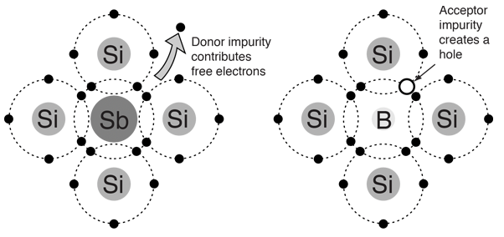

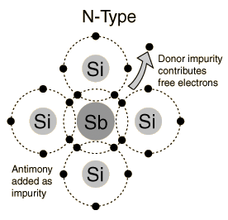**N-Type Semiconductor**

The addition of pentavalent impurities such as antimony, arsenic or phosphorus contributes free electrons, greatly increasing the conductivity of the intrinsic semiconductor. Phosphorus may be added by diffusion of phosphine gas (PH3). 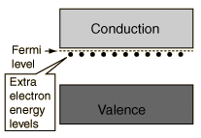

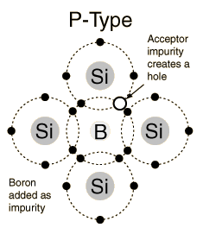**P-Type Semiconductor**

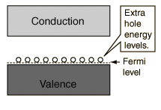The addition of trivalent impurities such as boron, aluminum or gallium to an intrinsic semiconductor creates deficiencies of valence electrons, called "holes". It is typical to use B2H6 diborane gas to diffuse boron into the  
silicon material.

**Bands for Doped Semiconductors**

The application of band theory to n-type and p-type semiconductors shows that extra levels have been added by the impurities. In n-type material there are electron energy levels near the top of the band gap so that they can be easily excited into the conduction band. In p-type material, extra holes in the band gap allow excitation of valence band electrons, leaving mobile holes in the   
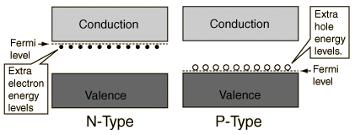valence band.

**P-N Junction**

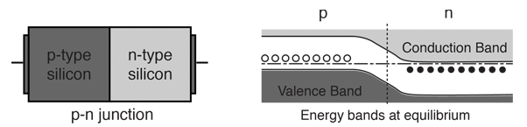One of the crucial keys to solid state electronics is the nature of the P-N junction. When p- type and n-type materials are placed in contact with each other, the junction behaves very differently than either type of material alone. Specifically, current will flow readily in one direction (forward biased) but not in the other (reverse biased), creating the basic diode. This non-reversing behavior arises from the nature of the charge transport process in the two types of materials.

The open circles on the left side of the junction above represent "holes" or deficiencies of electrons in the lattice which can act like positive charge carriers. The solid circles on the right of the junction represent the available electrons from the n-type dopant. Near the junction, electrons diffuse across to combine with holes, creating a "depletion region". The energy level sketch above right is a way to visualize the equilibrium condition of the P-N junction. The upward direction in the diagram represents increasing electron energy.

**Depletion Region**

When a p-n junction is formed, some of the free electrons in the n-region diffuse across the junction and combine with holes to form negative ions. In so doing they leave behind positive ions at the donor impurity sites.

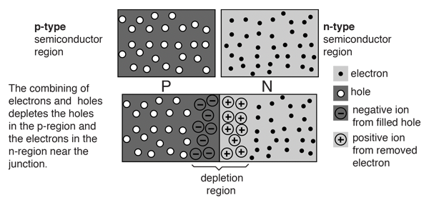

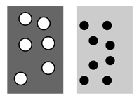**Depletion Region Details**

In the p-type region there are holes from the acceptor impurities and in the n-type region there are extra electrons.

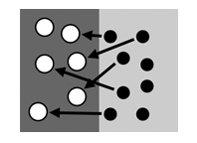

When a p-n junction is formed, some of the electrons from the n-region which have reached the conduction band are free to diffuse across the junction and combine with holes.

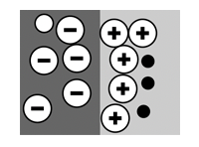

Filling a hole makes a negative ion and leaves behind a positive ion on the n-side. A space charge builds up, creating a depletion region which inhibits any further electron transfer unless it is helped by putting a forward bias on the junction.

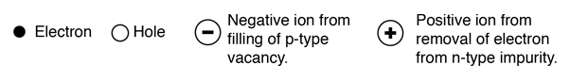

**Bias effect on electrons in depletion zone**

Equilibrium of junction

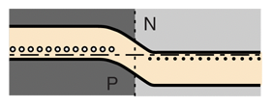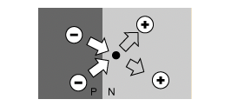Coulomb force from ions prevents further migration across the p-n junction. The electrons which had migrated across from the N to the P region in the forming of the depletion layer have now reached equilibrium. Other electrons from the N region cannot migrate because they are repelled by the negative ions in the P region and attracted by the positive ions in the N region.

Reverse bias

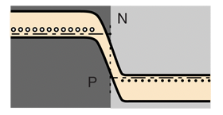An applied voltage with the indicated polarity further impedes the flow of electrons across the junction. For conduction in the device, electrons from the N region must move to the junction and combine with holes in the P region. A reverse voltage drives the electrons away from the junction, preventing conduction.

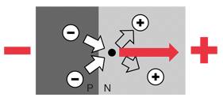

Forward bias

An applied voltage in the forward direction as indicated assists electrons in overcoming the coulomb barrier of the space charge in the depletion region. Electrons will flow with very small resistance in the forward direction.

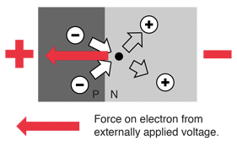

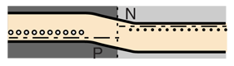

**Forward Biased P-N Junction**

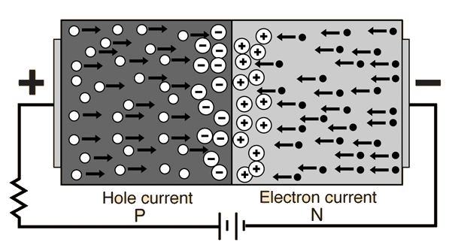Forward biasing the p-n junction drives holes to the junction from the p-type material and electrons to the junction from the n-type material. At the junction the electrons and holes combine so that a continuous current can be maintained.

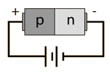

**Reverse Biased P-N Junction**

The application of a reverse voltage to the p-n junction will cause a transient current to flow as both electrons and holes are pulled away from the junction. When the potential formed by the widened depletion layer equals the applied voltage, the current will cease except for the small thermal current.

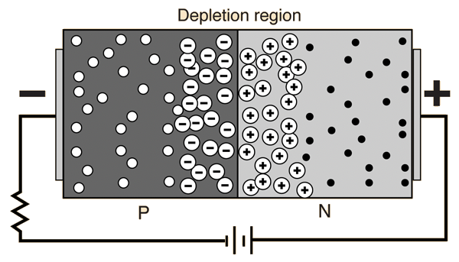

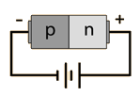

**The P-N Junction Diode**

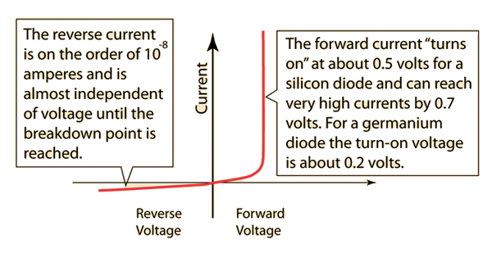The nature of the p-n junction is that it will conduct current in the forward direction but not in the reverse direction. It is therefore a basic tool for rectification in the building of DC power supplies.

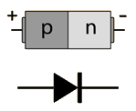

**The PIN Diode**

The PIN diode has heavily doped p-type and n-type regions separated by an intrinsic region. When reverse biased, it acts like an almost constant capacitance and when forward biased it behaves as a variable resistor.

The forward resistance of the intrinsic region decreases with increasing current. Since its forward resistance can be changed by varying the bias, it can be used as a modulating device for AC signals. It is used in microwave switching applications.

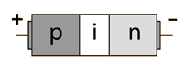

**Step-Recovery Diode**

In the step-recovery diode the doping level is gradually decreased as the junction is approached. This reduces the switching time since the smaller amount of stored charge near the junction can be released more rapidly when changing from forward to reverse bias.

The forward current can also be established more rapidly than in the ordinary junction diode. This diode is used in fast switching applications.

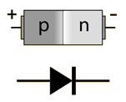

**Intrinsic Semiconductor**

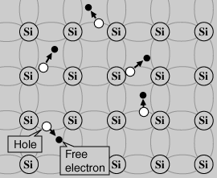A silicon crystal is different from an insulator because at any temperature above absolute zero temperature, there is a finite probability that an electron in the lattice will be knocked loose from its position, leaving behind an electron deficiency called a "hole".

If a voltage is applied, then both the electron and the hole can contribute to a small current flow.

The conductivity of a semiconductor can be modeled in terms of the band theory of solids. The band model of a semiconductor suggests that at ordinary temperatures there is a finite possibility that electrons can reach the conduction band and contribute to electrical conduction.

The term intrinsic here distinguishes between the properties of pure "intrinsic" silicon and the dramatically different properties of doped n-type or p-type semiconductors.

**Semiconductor Current**

Both electrons and holes contribute to current flow in an intrinsic semiconductor.

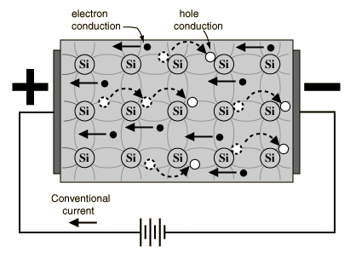

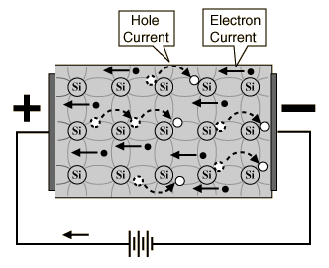**Semiconductor Current**

The current which will flow in an intrinsic semiconductor consists of both electron and hole current. That is, the electrons which have been freed from their lattice positions into the conduction band can move through the material.

In addition, other electrons can hop between lattice positions to fill the vacancies left by the freed electrons. This additional mechanism is called hole conduction because it is as if the holes are migrating across the material in the direction opposite to the free electron movement.

The current flow in an intrinsic semiconductor is influenced by the density of energy states which in turn influences the electron density in the conduction band. This current is highly temperature dependent.

**Electrons and Holes**

In an intrinsic semiconductor like silicon at temperatures above absolute zero, there will be some electrons which are excited across the band gap into the conduction band and which can produce current. When the electron in pure silicon crosses the gap, it leaves behind an electron vacancy or "hole" in the regular silicon lattice. Under the influence of an external voltage, both the electron and the hole can move across the material. In an n-type semiconductor, the dopant contributes extra electrons, dramatically increasing the conductivity. In a p-type semiconductor, the dopant produces extra vacancies or holes, which likewise increase the conductivity. It is however the behavior of the p-n junction which is the key to the enormous variety of solid-state electronic devices.

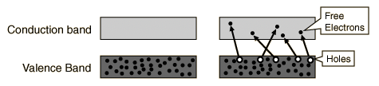

**Silicon and Germanium**

Solid state electronics arises from the unique properties of silicon and germanium, each of which has four valence electrons and which form crystal lattices in which substituted atoms (dopants) can dramatically change the electrical properties.

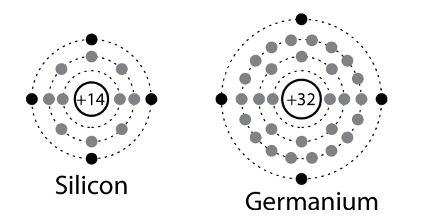

**Silicon**

In solid state electronics, either pure silicon or germanium may be used as the intrinsic semiconductor which forms the starting point for fabrication. Each has four valence electrons, but germanium will at a given temperature have more free electrons and a higher conductivity. Silicon is by far the more widely used semiconductor for electronics, partly because it can be used at much higher temperatures than germanium.

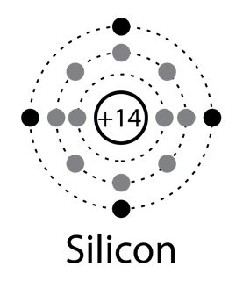

**Germanium**

In solid state electronics, either pure silicon or germanium may be used as the intrinsic semiconductor which forms the starting point for fabrication.

Each has four valence electrons, but germanium will at a given temperature have more free electrons and a higher conductivity. Silicon is by far the more widely used semiconductor for electronics, partly because it can be used at much higher temperatures than germanium.

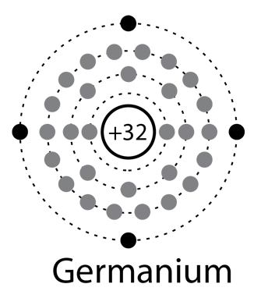

**Silicon Lattice**

Silicon atoms form covalent bonds and can crystallize into a regular lattice. The illustration below is a simplified sketch; the actual crystal structure of silicon is a diamond lattice. This crystal is called an intrinsic semiconductor and can conduct a small amount of current.

The main point here is that a silicon atom has four electrons which it can share in covalent bonds with its neighbors. These simplified diagrams do not do justice to the nature of that sharing since any one silicon atom will be influenced by more than four other silicon atoms, as may be appreciated by looking at the silicon unit cell.

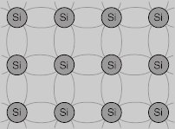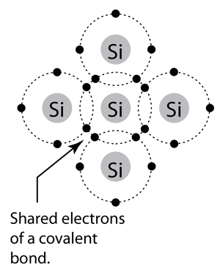

**Valence Electrons**

The electrons in the outermost shell of an atom are called valence electrons; they dictate the nature of the chemical reactions of the atom and largely determine the electrical nature of solid matter. The electrical properties of matter are pictured in the band theory of solids in terms of how much energy it takes to free a valence electron.

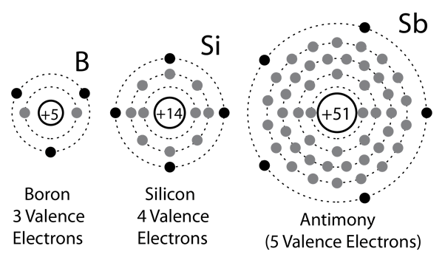

**Electric Current**

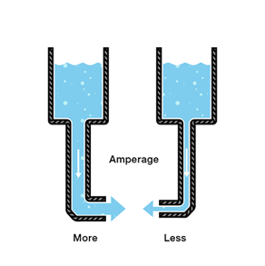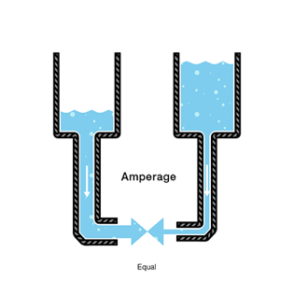Electric current is the rate of charge flow past a given point in an electric circuit, measured in Coulombs/second which is named Amperes. In most DC electric circuits, it can be assumed that the resistance to current flow is a constant so that the current in the circuit is related to voltage and resistance by Ohm's law. The standard abbreviations for the units are 1A = 1C/s.

* Water = Charge (measured in Coulombs)
* Pressure = Voltage (measured in Volts)
* Flow = Current (measured in Amperes, or “Amps” for short)
* Hose Width = Resistance 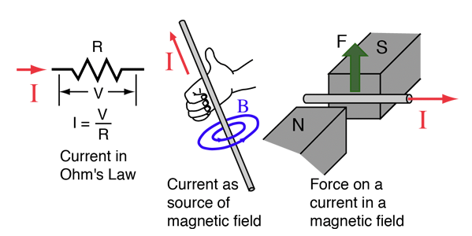

**Electric Charge**

Electricity is the movement of electrons. Electrons create charge, which we can harness to do work. Your lightbulb, your stereo, your phone, etc. are all harnessing the movement of electrons in order to do work. They all operate using the same basic power source: the movement of electrons.

The three basic principles for this tutorial can be explained using electrons, or more specifically, the charge they create:

* Voltage is the difference in charge between two points.
* Current is the rate at which charge is flowing.
* Resistance is a material’s tendency to resist the flow of charge (current).

The unit of electric charge is the Coulomb (abbreviated C). Ordinary matter is made up of atoms which have positively charged nuclei and negatively charged electrons surrounding them. Charge is quantized as a multiple of the electron or proton charge:

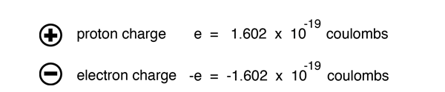

The influence of charges is characterized in terms of the forces between them (Coulomb's law) and the electric field and voltage produced by them. One Coulomb of charge is the charge which would flow through a 120 watt lightbulb (120 volts AC) in one second. Two charges of one Coulomb each separated by a meter would repel each other with a force of about a million tons!

The rate of flow of electric charge is called electric current and is measured in Amperes.

In introducing one of the fundamental properties of matter, it is perhaps appropriate to point out that we use simplified sketches and constructs to introduce concepts, and there is inevitably much more to the story. No significance should be attached to the circles representing the proton and electron, in the sense of implying a relative size, or even that they are hard sphere objects, although that's a useful first construct. The most important opening idea, electrically, is that they have a property called "charge" which is the same size, but opposite in polarity for the proton and electron. The proton has 1836 times the mass of the electron, but exactly the same size charge, only positive rather than negative. Even the terms "positive" and "negative" are arbitrary, but well-entrenched historical labels. The essential implication of that is that the proton and electron will strongly attract each other, the historical archtype of the cliche "opposites attract". Two protons or two electrons would strongly repel each other. Once you have established those basic ideas about electricity, "like charges repel and unlike charges attract", then you have the foundation for electricity and can build from there.

From the precise electrical neutrality of bulk matter as well as from detailed microscopic experiments, we know that the proton and electron have the same magnitude of charge. All charges observed in nature are multiples of these fundamental charges. Although the standard model of the proton depicts it as being made up of fractionally charged particles called quarks, those fractional charges are not observed in isolation -- always in combinations which produce +/- the electron charge.

An isolated single charge can be called an "electric monopole". Equal positive and negative charges placed close to each other constitute an electric dipole. Two oppositely directed dipoles close to each other are called an electric quadrupole. You can continue this process to any number of poles, but dipoles and quadrupoles are mentioned here because they find significant application in physical phenomena.

One of the fundamental symmetries of nature is the conservation of electric charge. No known physical process produces a net change in electric charge.

**Conventional Electric Current**

Although it is electrons which are the mobile charge carriers which are responsible for electric current in conductors such as wires, it has long been the convention to take the direction of electric current as if it were the positive charges which are moving. Some texts reverse this convention and take electric current direction as the direction the electrons move, an obviously more physically realistic direction, but the vast majority of references use the conventional current direction and that convention will be followed in most of this material. In common applications such as determining the direction of force on a current carrying wire, treating current as positive charge motion or negative charge motion gives identical results. Besides the advantage of agreeing in direction with most texts, the conventional current direction is the direction from high voltage to low voltage, high energy to low energy, and thus has some appeal in its parallel to the flow of water from high pressure to low (see water analogy).

**Voltage**

We define voltage as the amount of potential energy between two points on a circuit. One point has more charge than another. This difference in charge between the two points is called voltage. It is measured in volts, which, technically, is the potential energy difference between two points that will impart one joule of energy per coulomb of charge that passes through it (don’t panic if this makes no sense, all will be explained). The unit “volt” is named after the Italian physicist [**Alessandro Volta**](http://en.wikipedia.org/wiki/Allesandro_volta)who invented what is considered the first chemical battery. Voltage is represented in equations and schematics by the letter “V”.

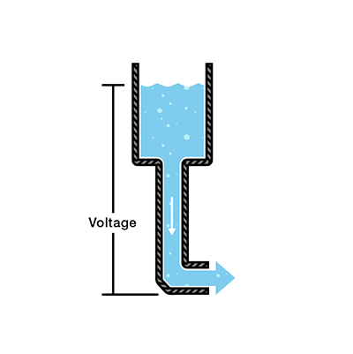When describing voltage, current, and resistance, a common analogy is a water tank. In this analogy, charge is represented by the water amount, voltage is represented by the water pressure, and current is represented by the water flow. So for this analogy, remember:

* Water = Charge
* Pressure = Voltage
* Flow = Current

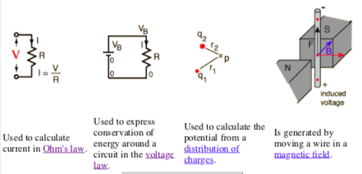Voltage is electric potential energy per unit charge, measured in joules per coulomb ( = volts). It is often referred to as "electric potential", which then must be distinguished from electric potential energy by noting that the "potential" is a "per-unit-charge" quantity. Like mechanical potential energy, the zero of potential can be chosen at any point, so the difference in voltage is the quantity which is physically meaningful. The difference in voltage measured when moving from point A to point B is equal to the work which would have to be done, per unit charge, against the electric field to move the charge from A to B. When a voltage is generated, it is sometimes called an "electromotive force" or emf.

**Resistance**

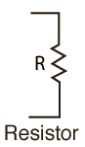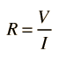The electrical resistance of a circuit component or device is defined as the ratio of the voltage applied to the electric current which flows through it:

If the resistance is constant over a considerable range of voltage, then Ohm's law, I = V/R, can be used to predict the behavior of the material. Although the definition above involves DC current and voltage, the same definition holds for the AC application of resistors.

Whether or not a material obeys Ohm's law, its resistance can be described in terms of its bulk resistivity. The resistivity, and thus the resistance, is temperature dependent. Over sizable ranges of temperature, this temperature dependence can be predicted from a temperature coefficient of resistance.

**Resistivity and Conductivity**

The electrical resistance of a wire would be expected to be greater for a longer wire, less for a wire of larger cross sectional area, and would be expected to depend upon the material out of which the wire is made. Experimentally, the dependence upon these properties is a straightforward one for a wide range of conditions, and the resistance of a wire can be expressed as

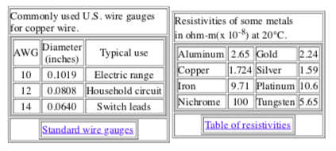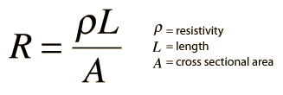The factor in the resistance which takes into account the nature of the material is the resistivity . Although it is temperature dependent, it can be used at a given temperature to calculate the resistance of a wire of given geometry.

It should be noted that it is being presumed that the current is uniform across the cross- section of the wire, which is true only for Direct Current. For Alternating Current there is the phenomenon of "skin effect" in which the current density is maximum at the maximum radius of the wire and drops for smaller radii within the wire. At radio frequencies, this becomes a major factor in design because the outer part of a wire or cable carries most of the current.

The inverse of resistivity is called conductivity. There are contexts where the use of conductivity is more convenient.

Electrical conductivity = σ = 1/ρ

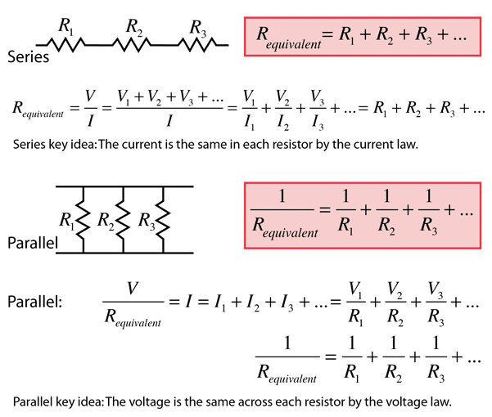**Resistor Combinations**The combination rules for any number of resistors in series or parallel can be derived with the use of Ohm's Law, the voltage law, and the current law.

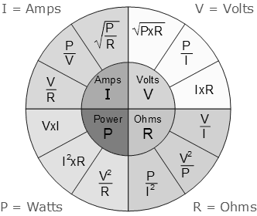

**Ohm's Law**

For many conductors of electricity, the electric current which will flow through them is directly proportional to the voltage applied to them. When a microscopic view of Ohm's law is taken, it is found to depend upon the fact that the drift velocity of charges through the material is proportional to the electric field in the conductor. The ratio of voltage to current is called the resistance, and if the ratio is constant over a wide range of voltages, the material is said to be an "ohmic" material. If the material can be characterized by such a resistance, then the current can be predicted from the relationship:

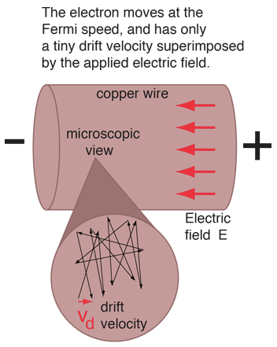Data can be entered into any of the boxes below. Specifying any two of the quantities determines the third. After you have entered values for two, click on the text representing the third in the active illustration above to calculate its value.

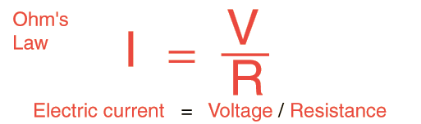

When electric current in a material is proportional to the voltage across it, the material is said to be "ohmic", or to obey Ohm's law. A microscopic view suggests that this proportionality comes from the fact that an applied electric field superimposes a small drift velocity on the free electrons in a metal. For ordinary currents, this drift velocity is on the order of millimeters per second in contrast to the speeds of the electrons themselves which are on the order of a million meters per second. Even the electron speeds are themselves small compared to the speed of transmission of an electrical signal down a wire, which is on the order of the speed of light, 300 million meters per second.

page58image5569152The current density (electric current per unit area, J=I/A) can be expressed in terms of the free electron density as

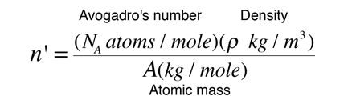The number of atoms per unit volume (and the number free electrons for atoms like copper that have one free electron per atom) is

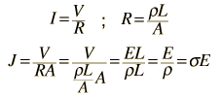From the standard form of Ohm's law and resistance in terms of resistivity:

page59image5744800The next step is to relate the drift velocity to the electron speed, which can be approximated by the Fermi speed:

page59image5735648The drift speed can be expressed in terms of the accelerating electric field E, the electron mass, and the characteristic time between collisions.

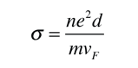The conductivity of the material can be expressed in terms of the Fermi speed and the mean free path of an electron in the metal.

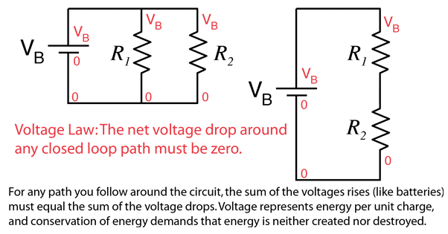**Voltage Law**

The voltage changes around any closed loop must sum to zero. No matter what path you take through an electric circuit, if you return to your starting point you must measure the same voltage, constraining the net change around the loop to be zero. Since voltage is electric potential energy per unit charge, the voltage law can be seen to be a consequence of conservation of energy.

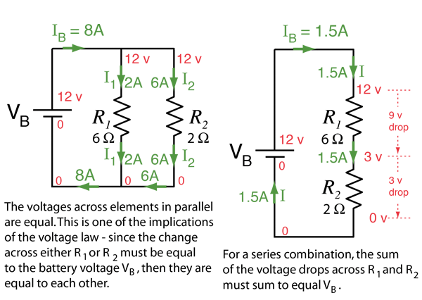The voltage law has great practical utility in the analysis of electric circuits. It is used in conjunction with the current law in many circuit analysis tasks.

The voltage law is one of the main tools for the analysis of electric circuits, along with Ohm's Law, the current law and the power relationship. Applying the voltage law to the above circuits along with Ohm's law and the rules for combining resistors gives the numbers shown below. The determining of the voltages and currents associated with a particular circuit along with the power allows you to completely describe the electrical state of a direct current circuit.

**Current Law**

The electric current in amperes that flows into any junction in an electric circuit is equal to the current which flows out. This can be seen to be just a statement of conservation of charge. Since you do not lose any charge during the flow process around the circuit, the total current in any cross-section of the circuit is the same. Along with the voltage law, this law is a powerful tool for the analysis of electric circuits.

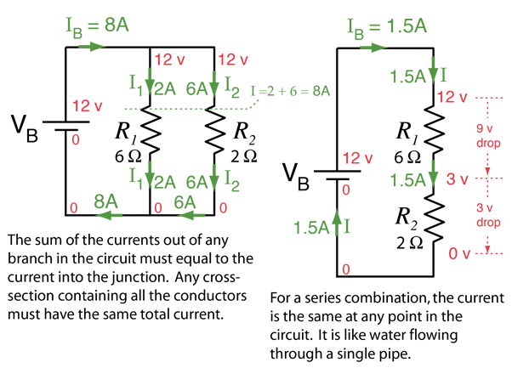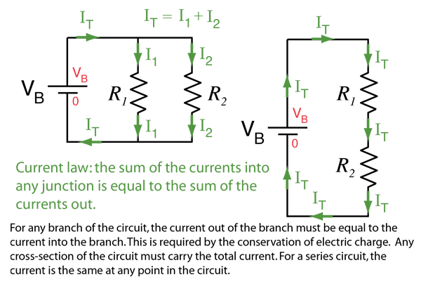The current law is one of the main tools for the analysis of electric circuits, along with Ohm's Law, the voltage law and the power relationship. Applying the current law to the above circuits along with Ohm's law and the rules for combining resistors gives the numbers shown below. The determining of the voltages and currents associated with a particular circuit along with the power allows you to completely describe the electrical state of a direct current circuit.

**(Energy) Band Theory of Solids**

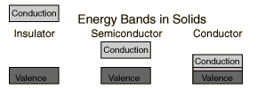A useful way to visualize the difference between conductors, insulators and semiconductors is to plot the available energies for electrons in the materials. Instead of having discrete energies as in the case of free atoms, the available energy states form bands. Crucial to the conduction process is whether or not there are electrons in the conduction band. In insulators the electrons in the valence band are separated by a large gap from the conduction band, in conductors like metals the valence band overlaps the conduction band, and in semiconductors there is a small enough gap between the valence and conduction bands that thermal or other excitations can bridge the gap. With such a small gap, the presence of a small percentage of a doping material can increase conductivity dramatically.

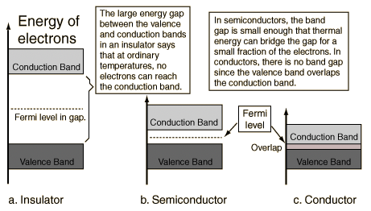An important parameter in the band theory is the Fermi level, the top of the available electron energy levels at low temperatures. The position of the Fermi level with the relation to the conduction band is a crucial factor in determining electrical properties.

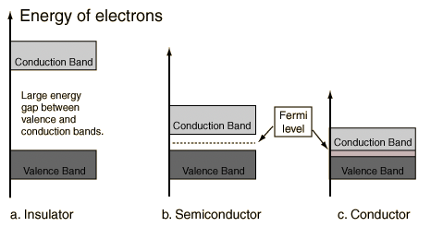

**Insulator Energy Bands**

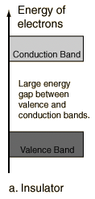Most solid substances are insulators, and in terms of the band theory of solids this implies that there is a large forbidden gap between the energies of the valence electrons and the energy at which the electrons can move freely through the material (the conduction band).

Glass is an insulating material which may be transparent to visible light for reasons closely correlated with its nature as an electrical insulator. The visible light photons do not have enough quantum energy to bridge the band gap and get the electrons up to an available energy level in the conduction band. The visible properties of glass can also give some insight into the effects of "doping" on the properties of solids. A very small percentage of impurity atoms in the glass can give it color by providing specific available energy levels which absorb certain colors of visible light. The ruby mineral (corundum) is aluminum oxide with a small amount (about 0.05%) of chromium which gives it its characteristic pink or red color by absorbing green and blue light.

While the doping of insulators can dramatically change their optical properties, it is not enough to overcome the large band gap to make them good conductors of electricity. However, the doping of semiconductors has a much more dramatic effect on their electrical conductivity and is the basis for solid state electronics.

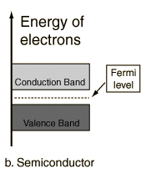**Semiconductor Energy Bands**

For intrinsic semiconductors like silicon and germanium, the Fermi level is essentially halfway between the valence and conduction bands. Although no conduction occurs at 0 K, at higher temperatures a finite number of electrons can reach the conduction band and provide some current. In doped semiconductors, extra energy levels are added.

The increase in conductivity with temperature can be modeled in terms of the Fermi function, which allows one to calculate the population of the conduction band.

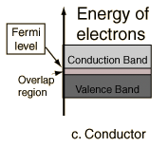**Conductor Energy Bands**

In terms of the band theory of solids, metals are unique as good conductors of electricity. This can be seen to be a result of their valence electrons being essentially free. In the band theory, this is depicted as an overlap of the valence band and the conduction band so that at least a fraction of the valence electrons can move through the material.

**Silicon Energy Bands**

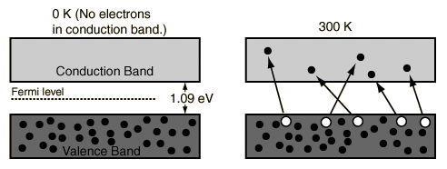At finite temperatures, the number of electrons which reach the conduction band and contribute to current can be modeled by the Fermi function. That current is small compared to that in doped semiconductors under the same conditions.

**Germanium Energy Bands**

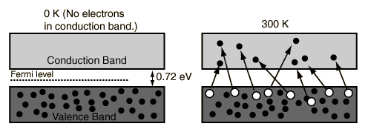At finite temperatures, the number of electrons which reach the conduction band and contribute to current can be modeled by the Fermi function. That current is small compared to that in doped semiconductors under the same conditions.